CASE-STUDY (NUMBER - 11) – SOLUTION SUBMISSION

ON

AZURE ANALYTICS

BY

NAME –SUPRIYA BHARATHA ROLL NUMBER DXCAB1211

BATCH:DXC-262-ANALYTICS-B12-AZURE COMPANY – DXC TECHNOLOGY

TRAINING UNDER – MANIPAL PRO LEARN TRAINER NAME – MR. AJAY KUMAR DATE OF SUBMISSION – 17th JUNE 2022 TOTAL NUMBER OF QUESTIONS: 08

EMPLOYEE DOMAIN - AZURE ANALYTICS

* THE QUESTIONS:

1. Write a python program to pridict car sales of a company by using below data,

year : 2010 2011 2012 2013 2014 2015 2016 2017 2018 2019 2020  
Sales in millions: 169 199 262 301 345 398 501 595 610 700 720  
display outcome using linear regression method

2. Write python program to generate possible tuples from any two sample Lists

3. Create Azure Databricks & try to connect databricks & powerBI ,  
explain the steps with screenshots.

4.Create Azure Synapse & connect with Azure Blob, explain the steps with screenshots

5.Create Azure Synapse spark pool & query sample sample JSON file,  
explain the steps with screenshots

6.Create Azure Cosmos DB & import sample JSON file, explain the steps with screenshots

7.Connect COSMOS DB & Azure Synapse analytics & explain the steps with screenshots

8.Create azure Data factory & azure Blob, connect Blob & ADF, import blob files into Data factory & explain the steps with screenshots

1. Write a python program to pridict car sales of a company by using below data,

year : 2010 2011 2012 2013 2014 2015 2016 2017 2018 2019 2020

Sales in millions: 169 199 262 301 345 398 501 595 610 700 720

display outcome using linear regression method

SOLUTION

* For predicting the car sales we need to import and then enter the details or the values of year and sales in millions in python code as shown below.

#Car sales prediction using linear regression

#library import

#import matplotlib,nmpy and sklearn

import matplotlib.pyplot as plt

import numpy as np

#importing model from scikit-learn

from sklearn import linear_model

#loading the datasets

Year=[2010, 2011, 2012, 2013, 2014, 2015, 2016, 2017, 2018, 2019, 2020]

Sales_in_millions=[69, 199, 262, 301, 345, 398, 501, 595, 610, 700, 720]

print(Sales_in_millions)

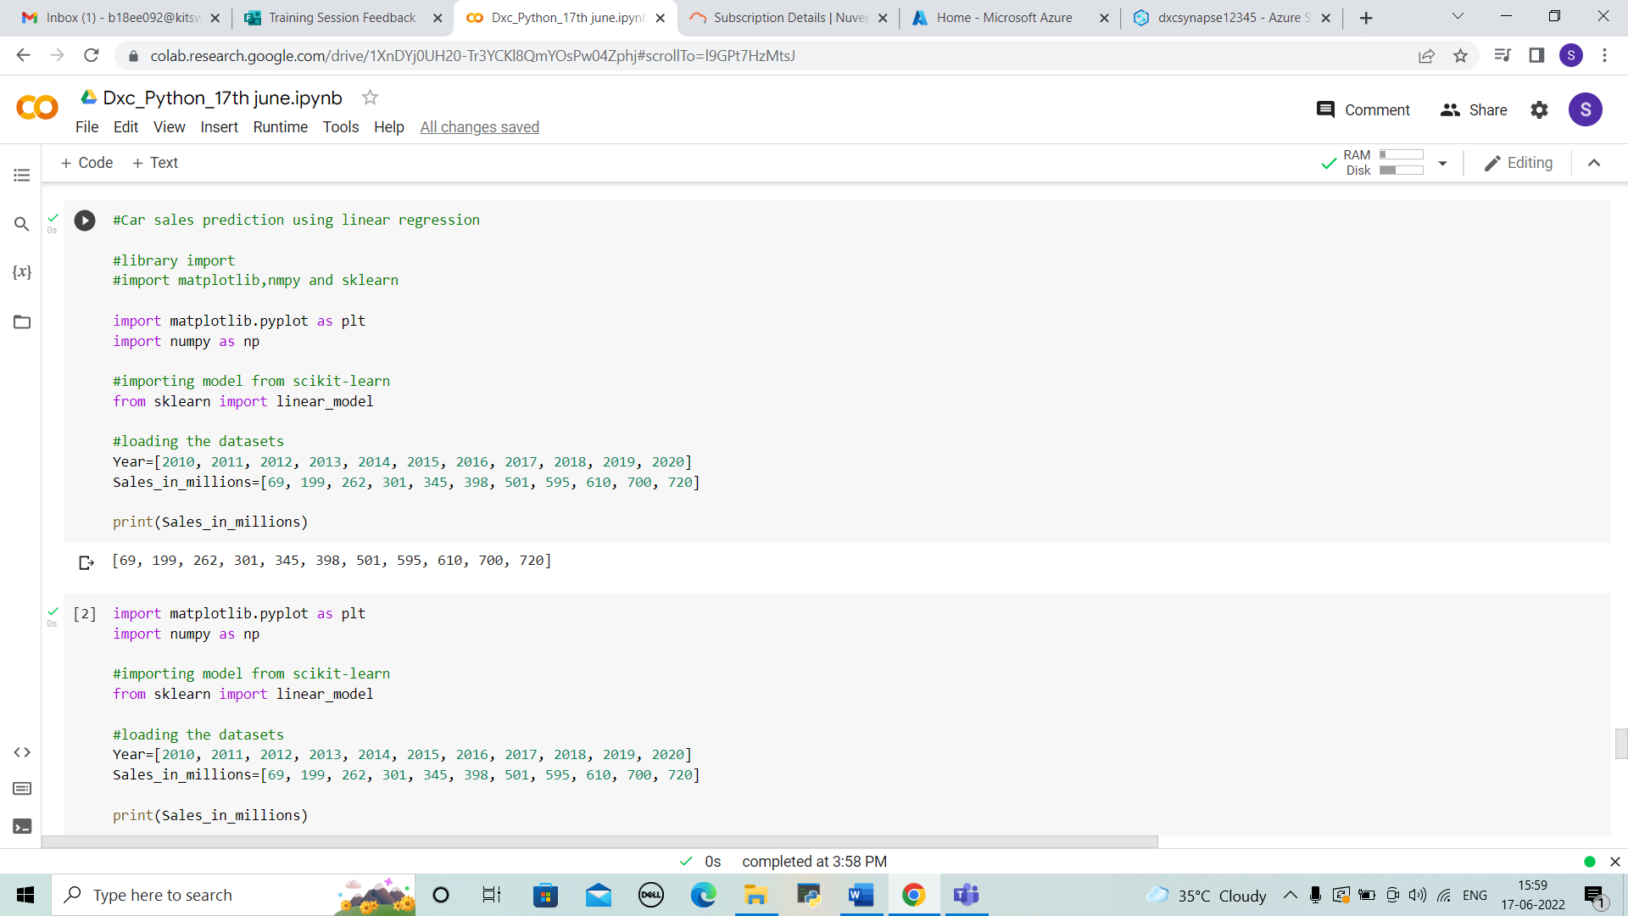

* Now we have to reshape the data to input after loading the datasets, and we print the new sales in millions as output.

import matplotlib.pyplot as plt

import numpy as np

#importing model from scikit-learn

from sklearn import linear_model

#loading the datasets

Year=[2010, 2011, 2012, 2013, 2014, 2015, 2016, 2017, 2018, 2019, 2020]

Sales_in_millions=[69, 199, 262, 301, 345, 398, 501, 595, 610, 700, 720]

print(Sales_in_millions)

#reshaping data to input

new_Sales_in_millions=np.array(Sales_in_millions).reshape(-1,1)

print(new_Sales_in_millions)

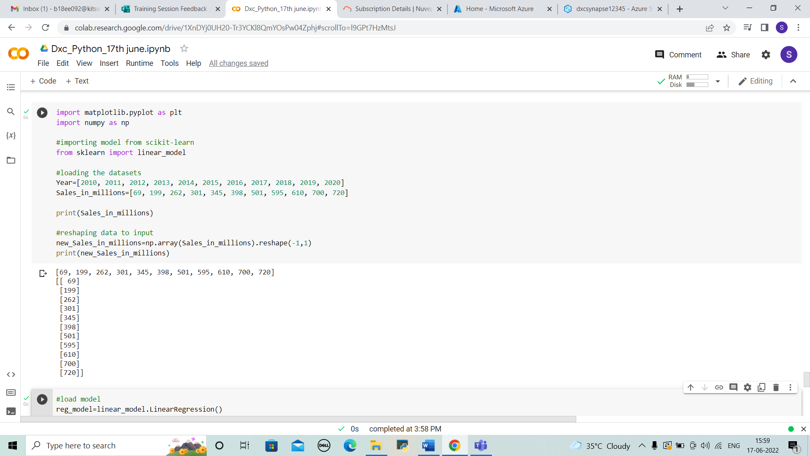

* Enter the details of coefficient and intercept and plot the pridictions using python code as shown below.

#load model

reg_model=linear_model.LinearRegression()

#fir data into model

reg_model.fit(new_Sales_in_millions,Year)

#coeffiecient

print("Coefficient :",reg_model.coef_)

#intercept

print("Intercept :",reg_model.intercept_)

def graph(formula,x_range):

  x=np.array(x_range)

  y=eval(formula)

  plt.plot(x,y)

#plotting the predictions

graph('reg_model.coef_*x+reg_model.intercept_',range(100,700))

plt.scatter(new_Sales_in_millions,Year,color='orange')

plt.ylabel("Sales_in_millions")

plt.xlabel("Year")

plt.show()

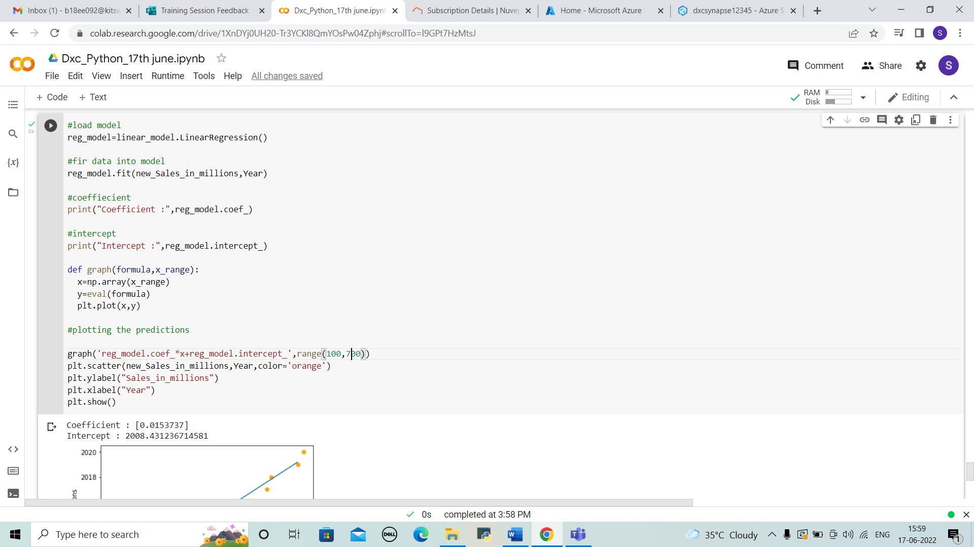

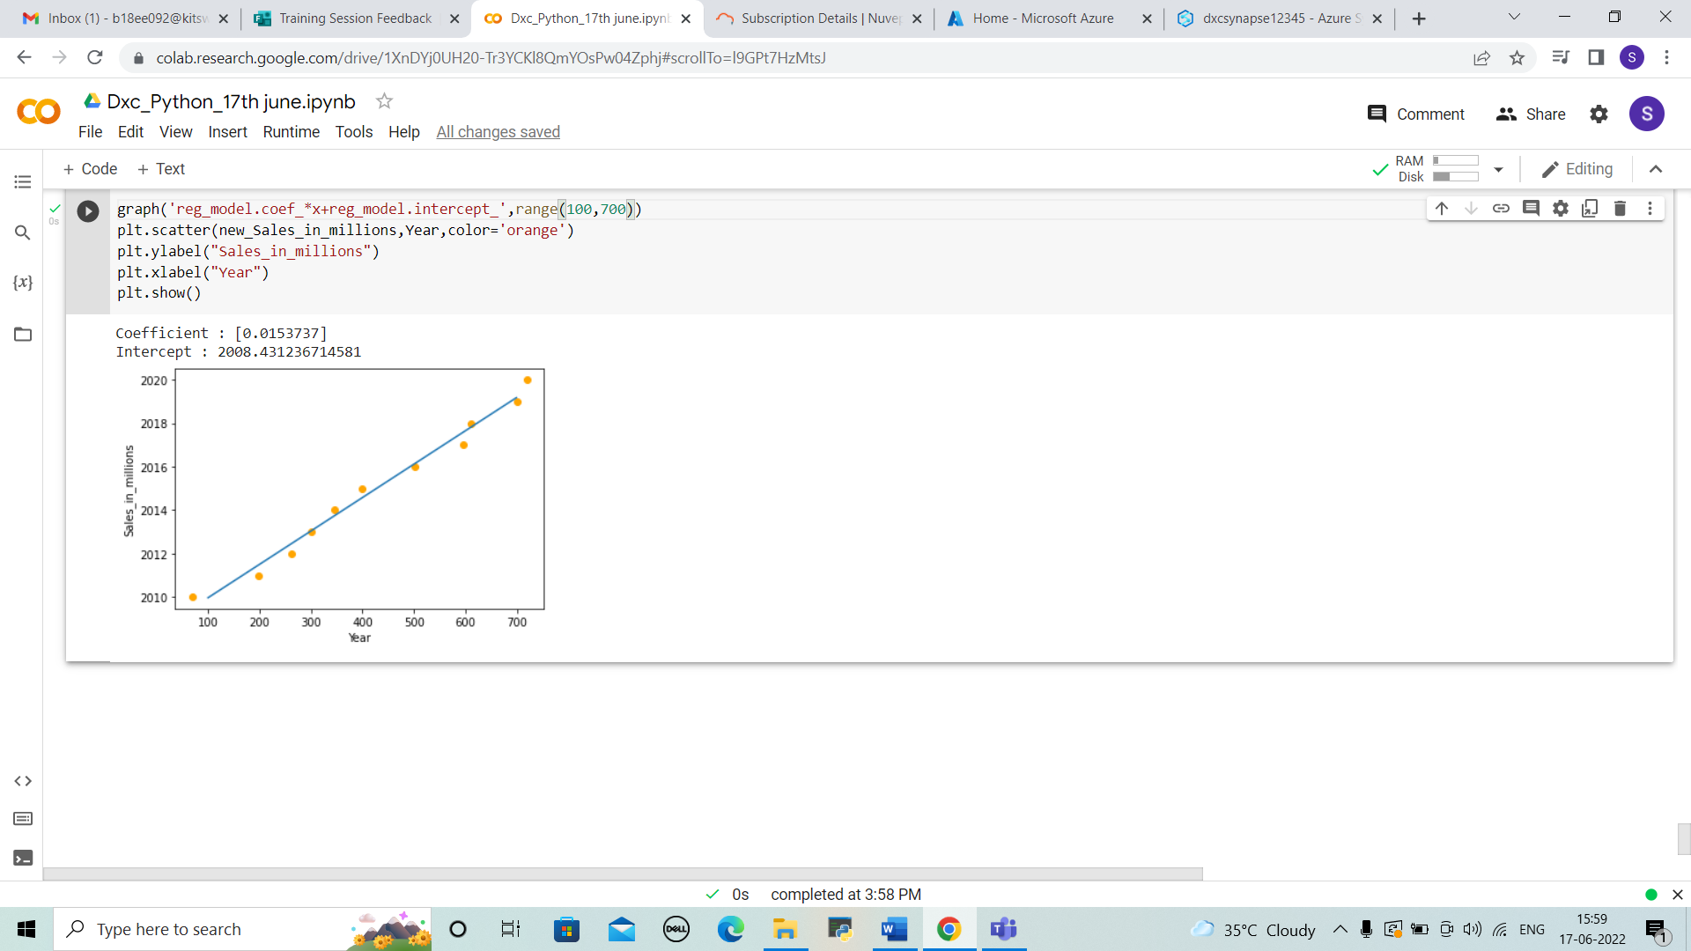



2. Write python program to generate possible tuples from any two sample Lists

SOLUTION

* For generating possible tuples from two sample lists. Enter the data 1,2 and print them. And then we can print the tuples by below code in python and we can see output.

mydata1 = (10, 15)

mydata2 = (6, 9)

print("The original tuple 1: " + str(mydata1))

print("The original tuple 1: " + str(mydata2))

# All pair combinations of 2 tuples list comprehension

res = [(a, b) for a in mydata1 for b in mydata2 ]

res = res+ [(a, b) for a in mydata2 for b in mydata1 ]

#print the result

print("The filtered tuple: " + str(res))

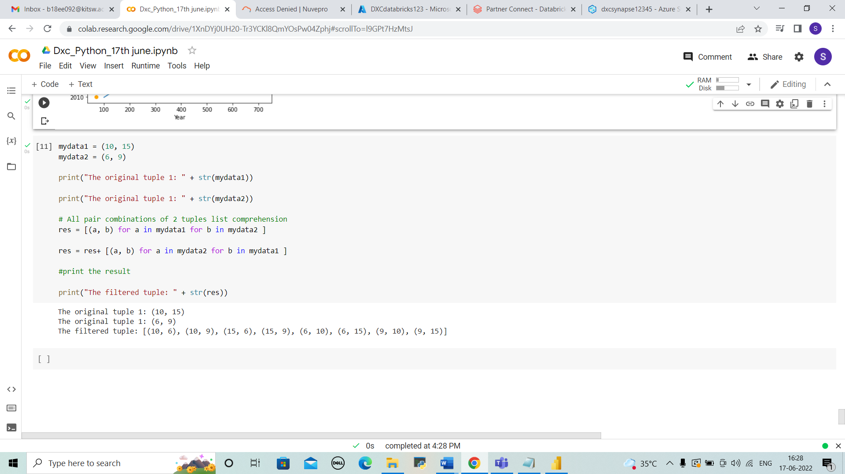

3. Create Azure Databricks & try to connect databricks & powerBI , explain the steps with screenshots.

SOLUTION

STEP 1 : Open azure portal and search for databricks and select it. And click on “+create”.

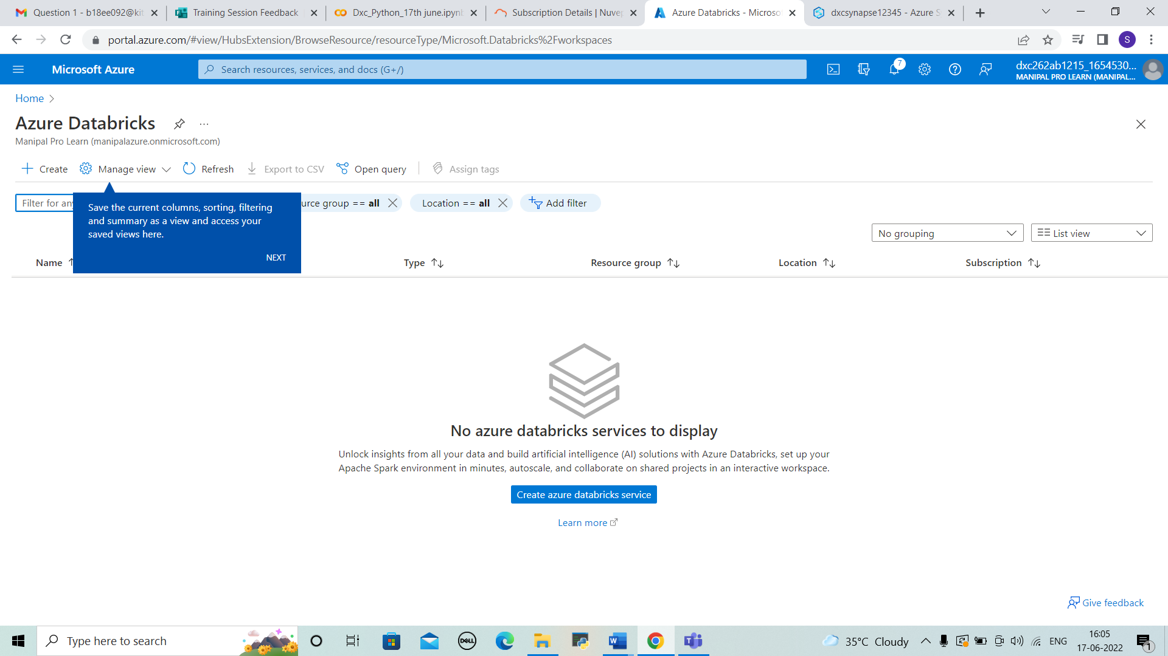



STEP 2: Enter the details of resource group ,workspace name, region and pricing tier and click on review+create.

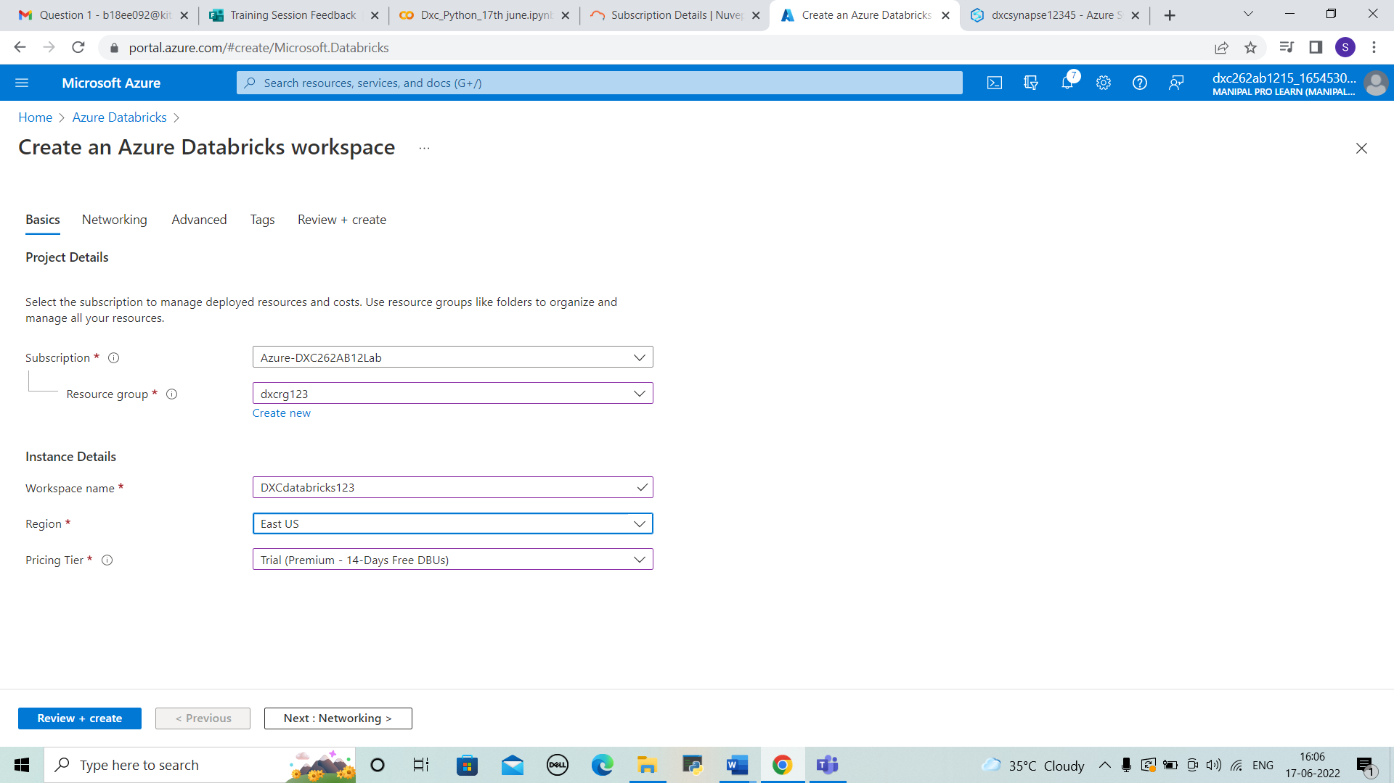



STEP 3: Validation is passed and click on create. The deployment will be under progress.

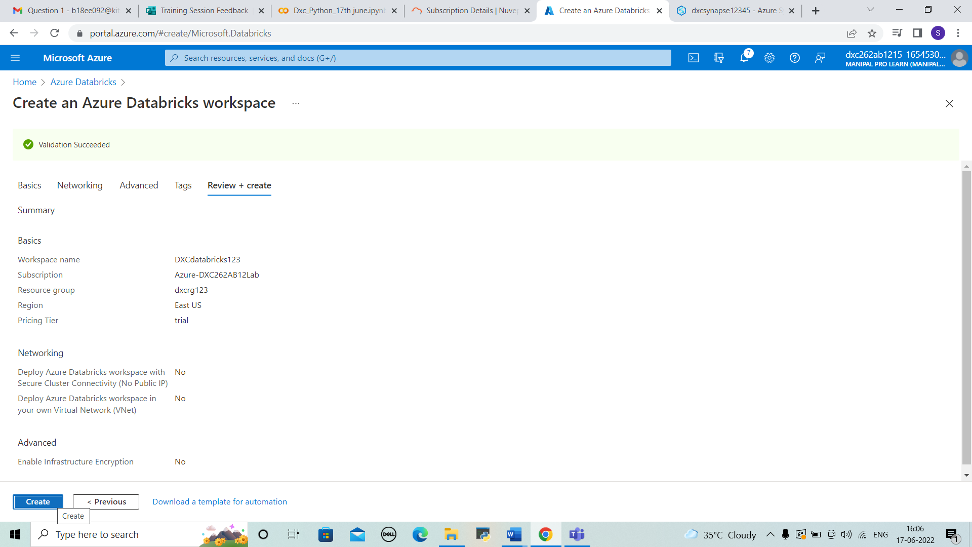



STEP 4: After few minutes we can observe the deployment is completed. And then go to resource.

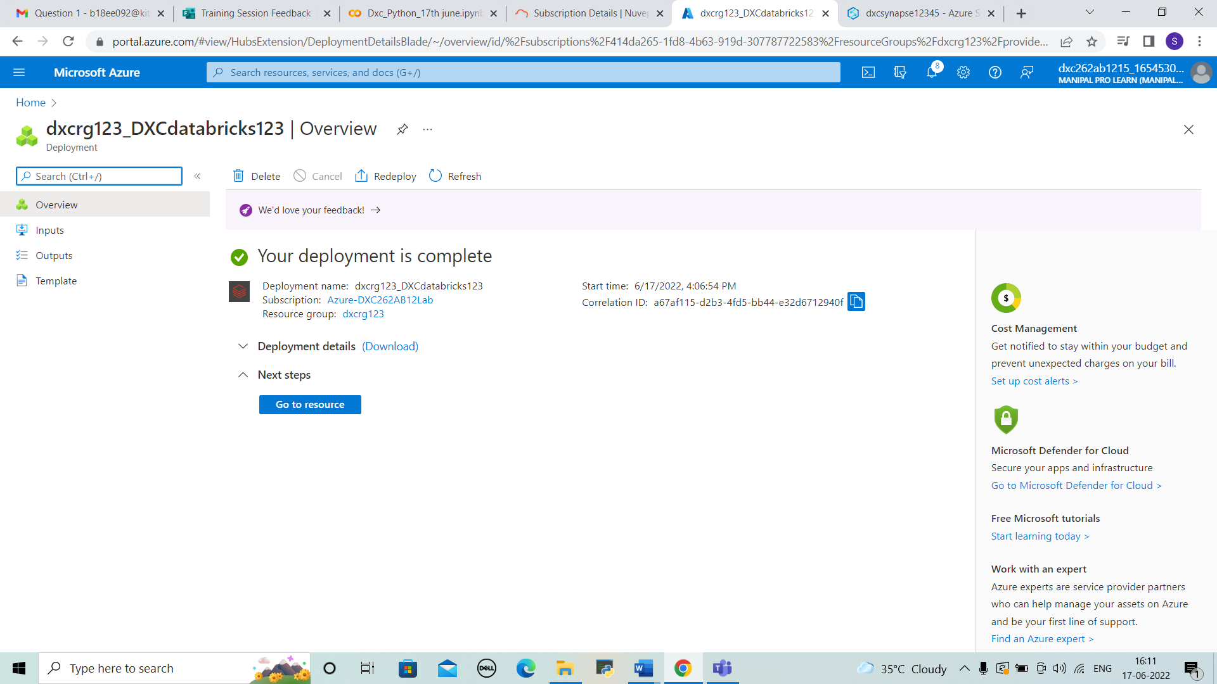



STEP 5 : We can view the overview of databricks and click on launch workspace.

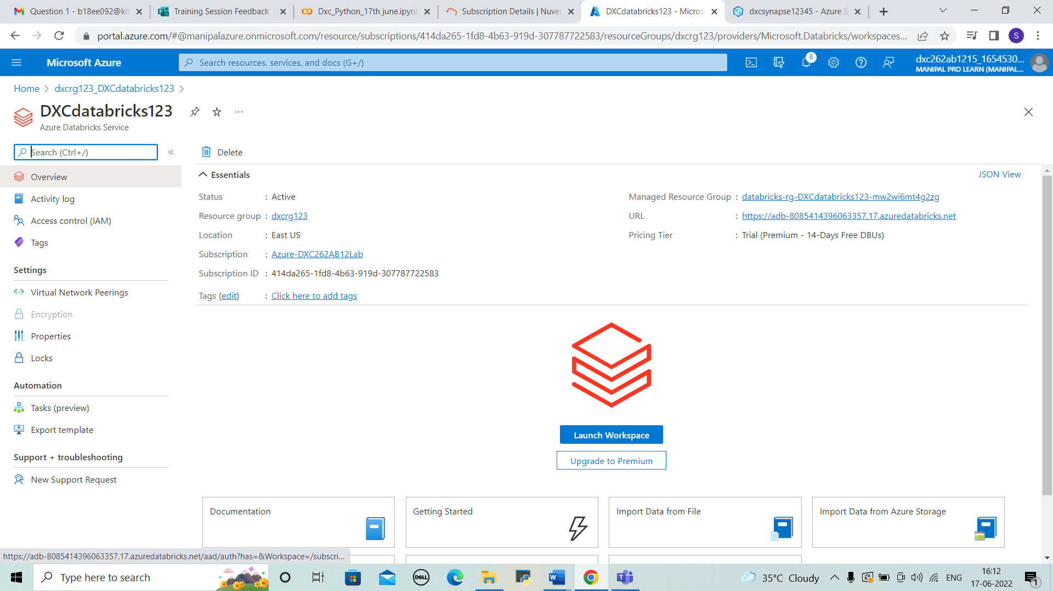



STEP 6: After that we can see a new page of databricks

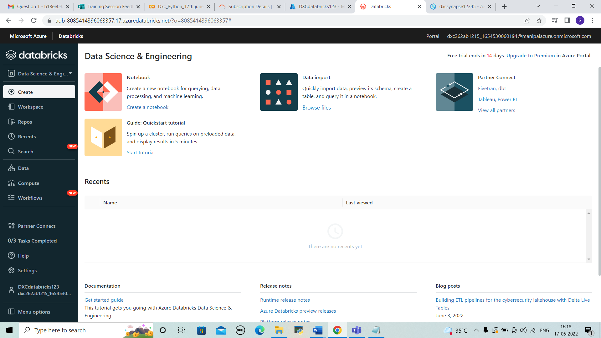



STEP 7: Go to settings > user settings . There we can generate a new token by entering the comment and lifetime.

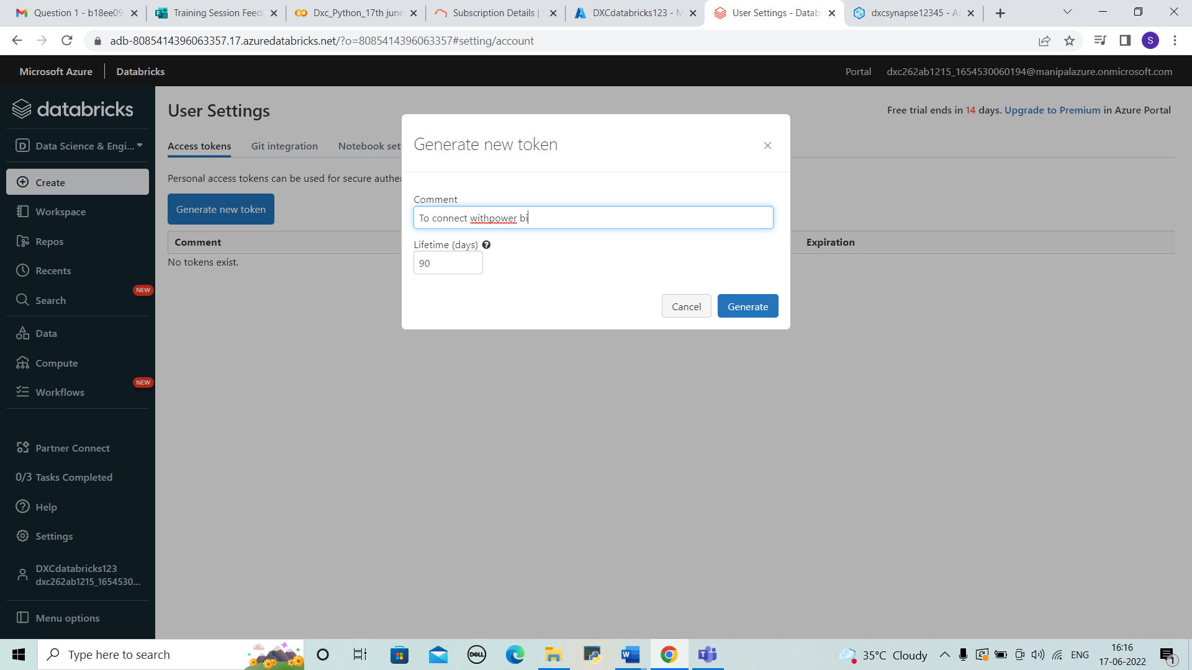



STEP 8: The token is generated. And copy it to the notepad which can be used later.

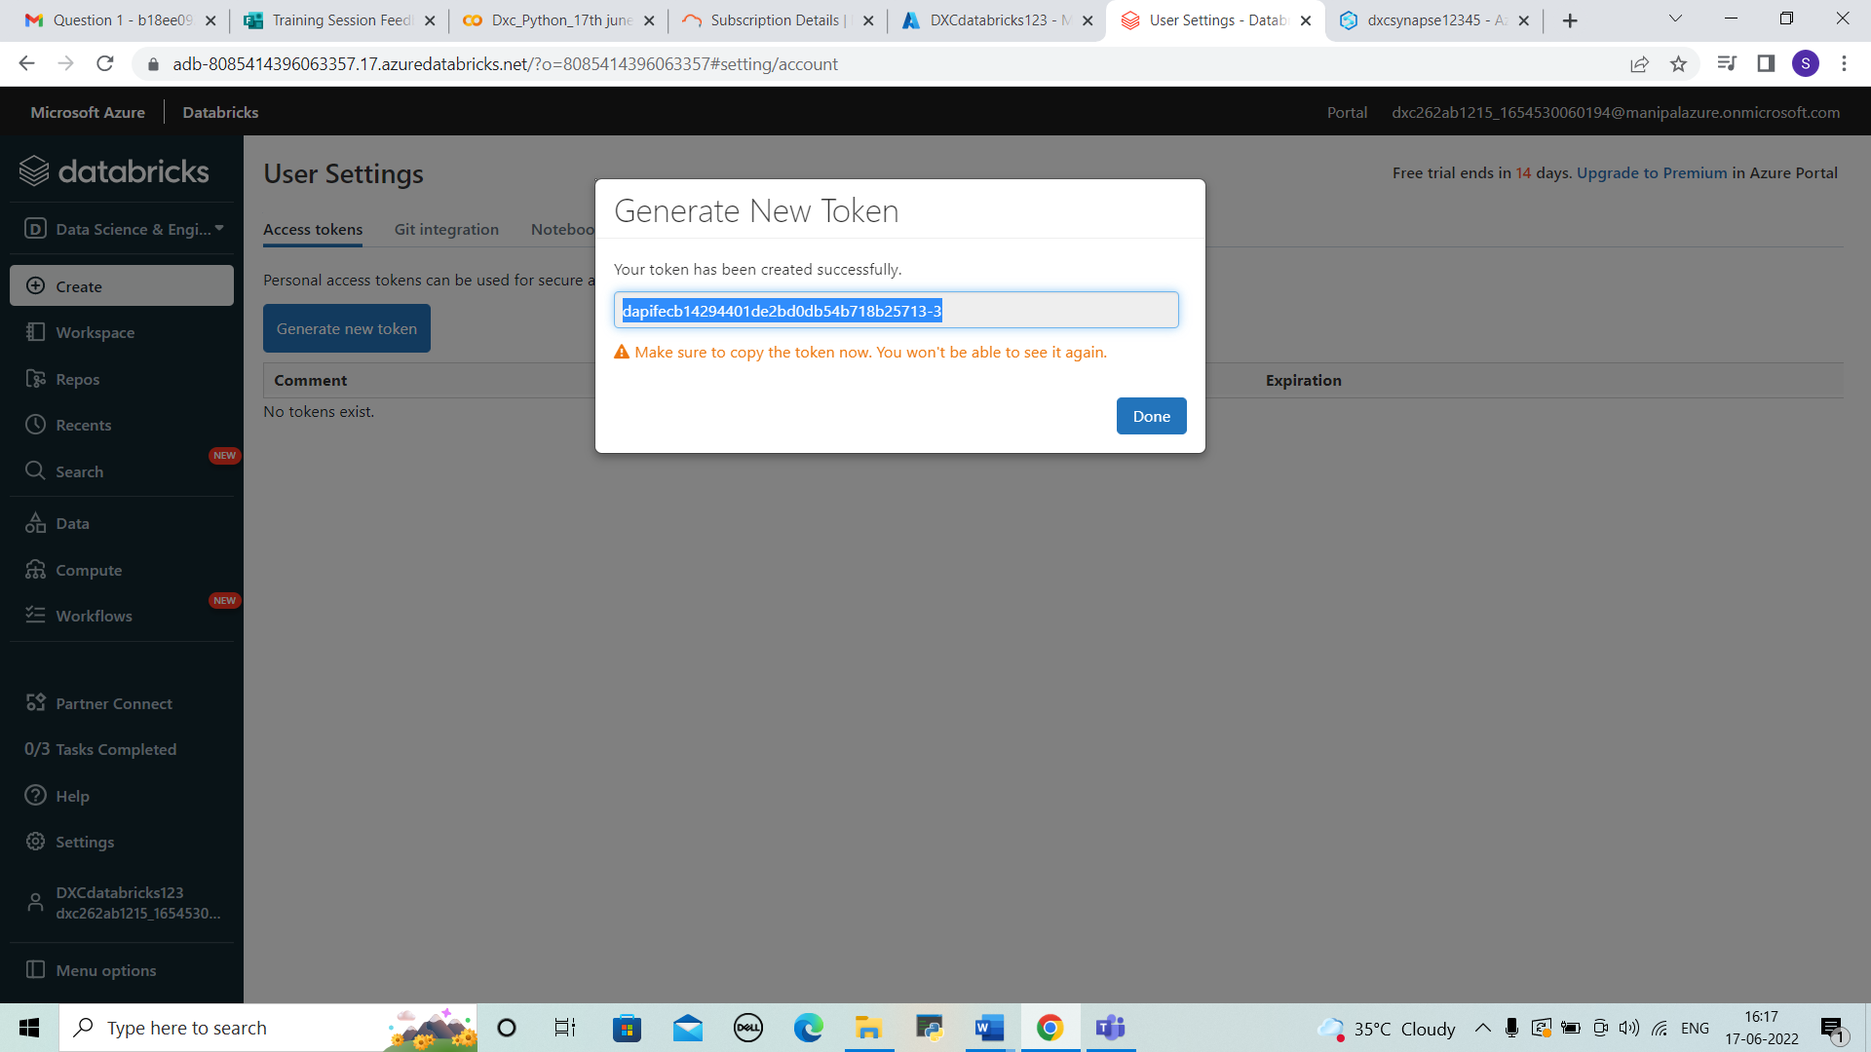



STEP 9: In data section open create table and upload the file as shown below. And select partner connect.

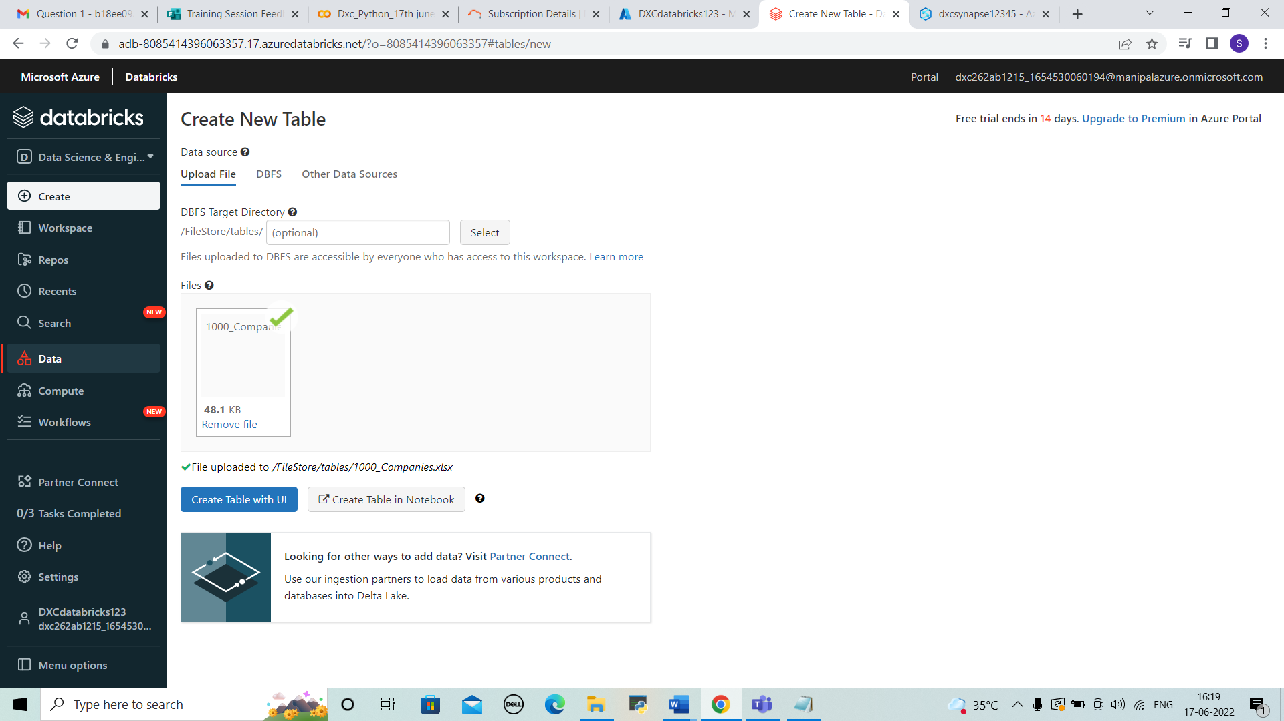



STEP 10: There select the Microsoft power bi . Then we need to download a file and open it.

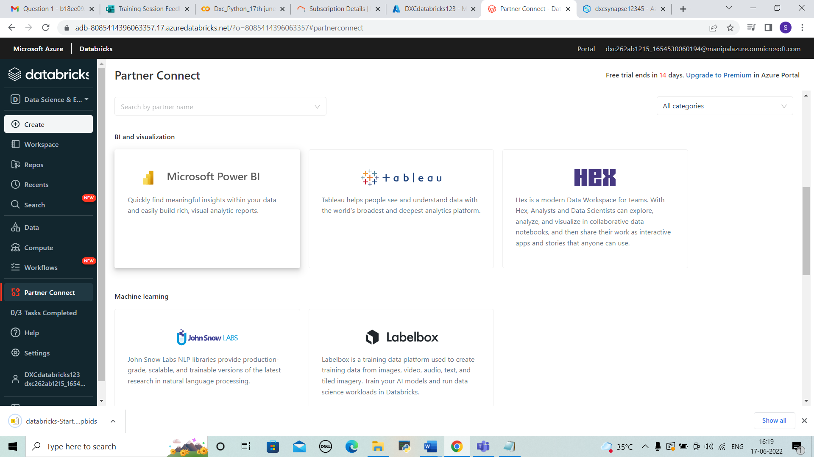



STEP 11: We can see a tab showing to enter token. Now paste the token that we saved and then click on connect. The data is shown in powerbi.

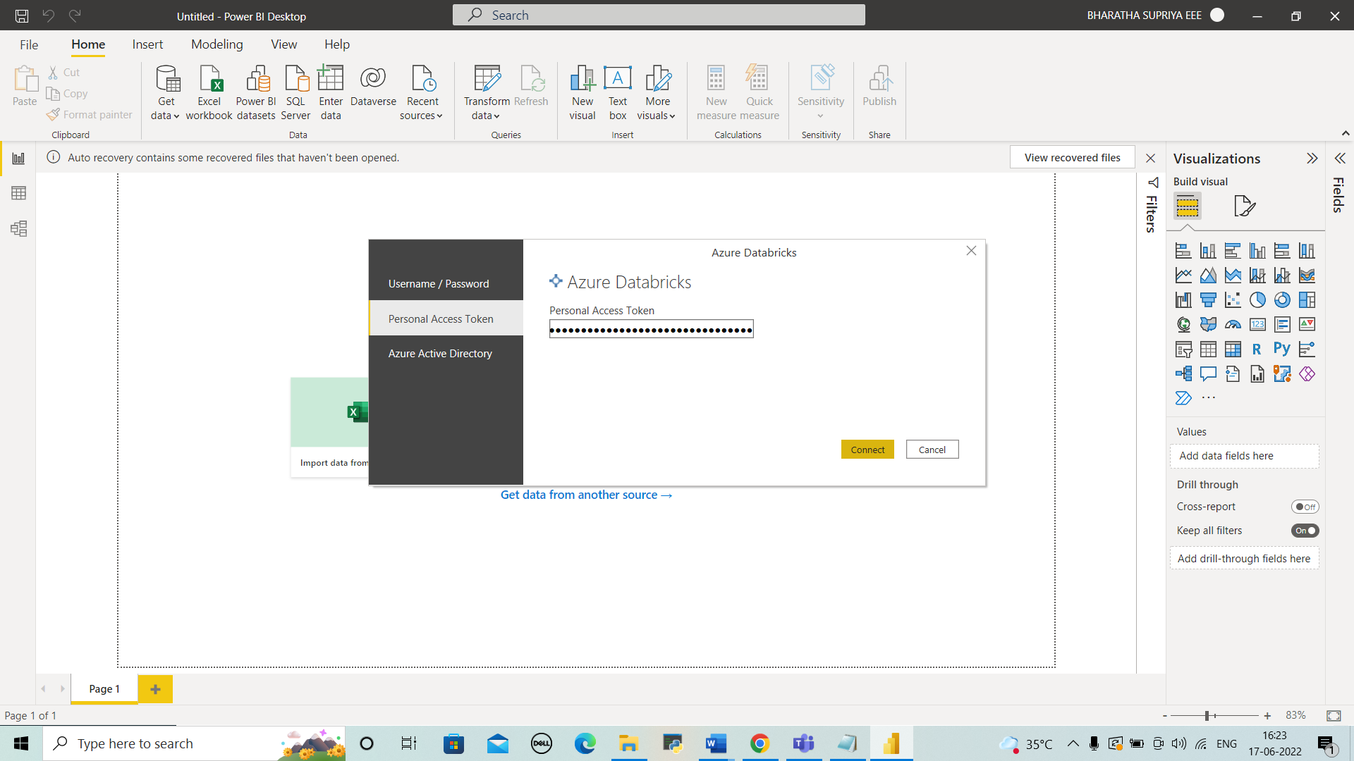



4.Create Azure Synapse & connect with Azure Blob, explain the steps with screenshots

SOLUTION

STEP 1: Open azure portal search for synapse analytics and select it. Click on “+create”

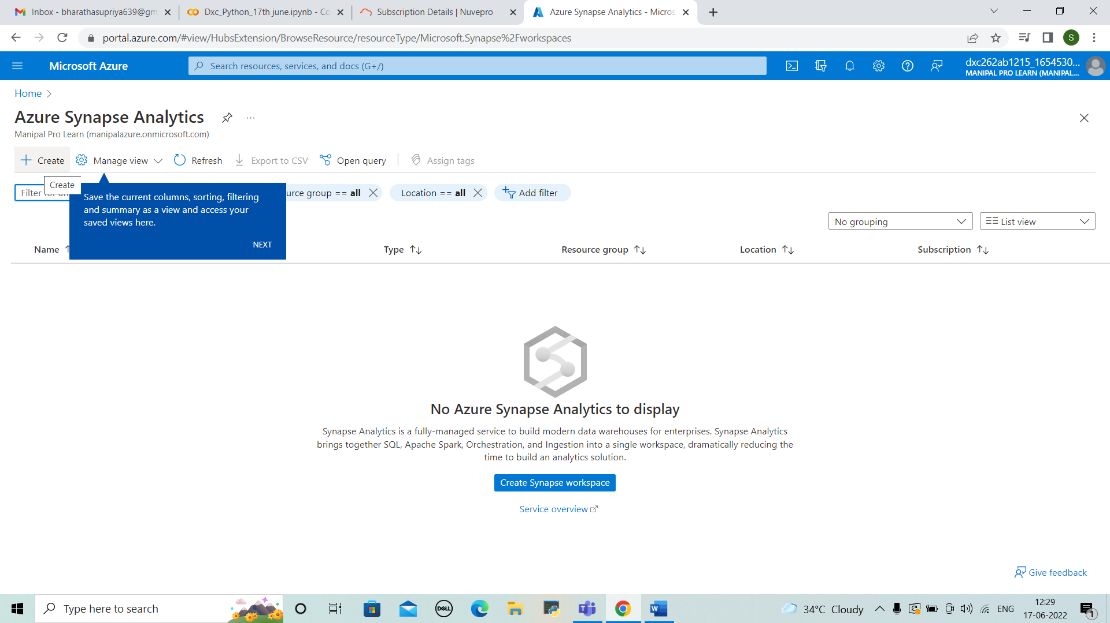



STEP 2: Enter the details of resource group , workspace name and region , account name, file system name and click on next security.

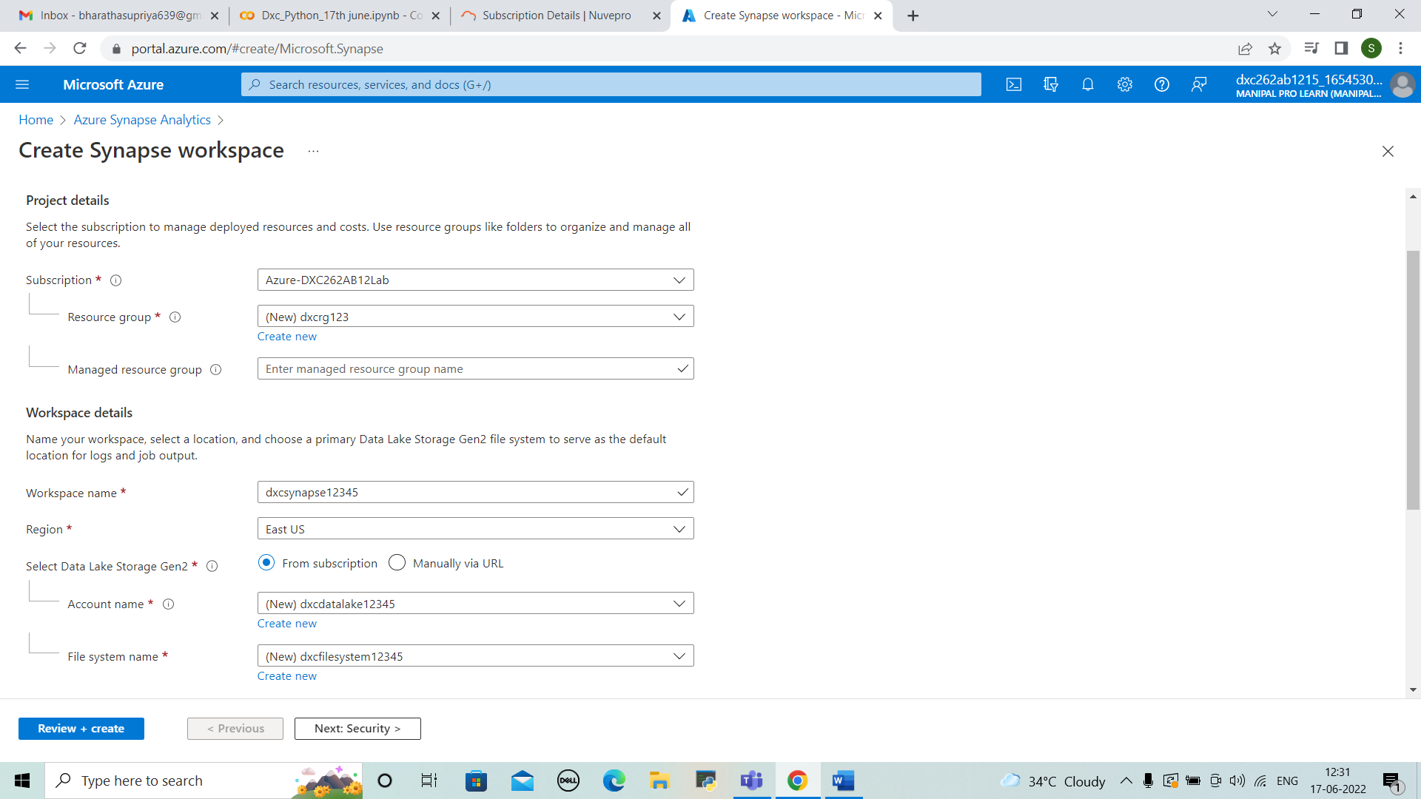



STEP 3: In security enter server admin login and sql password and confirm it. Then click on review+create.

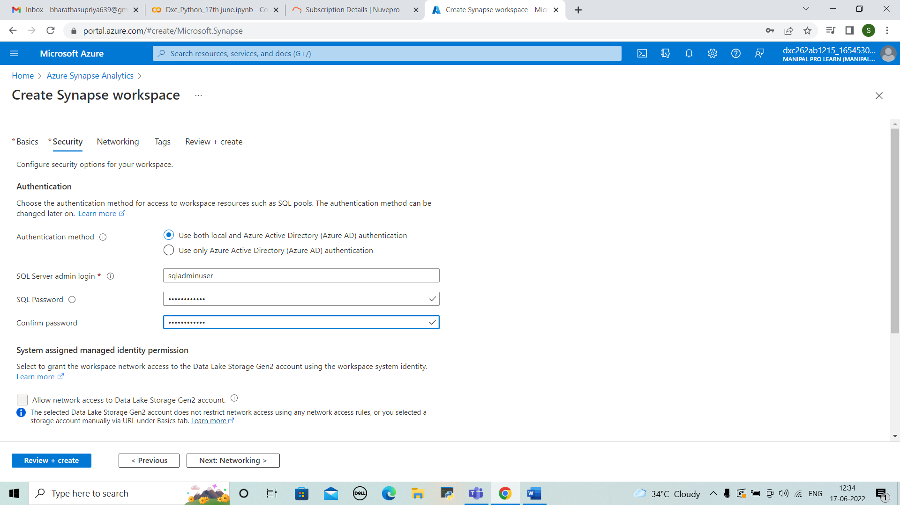



STEP 4: Then validation is passed. And check the details and click on create.

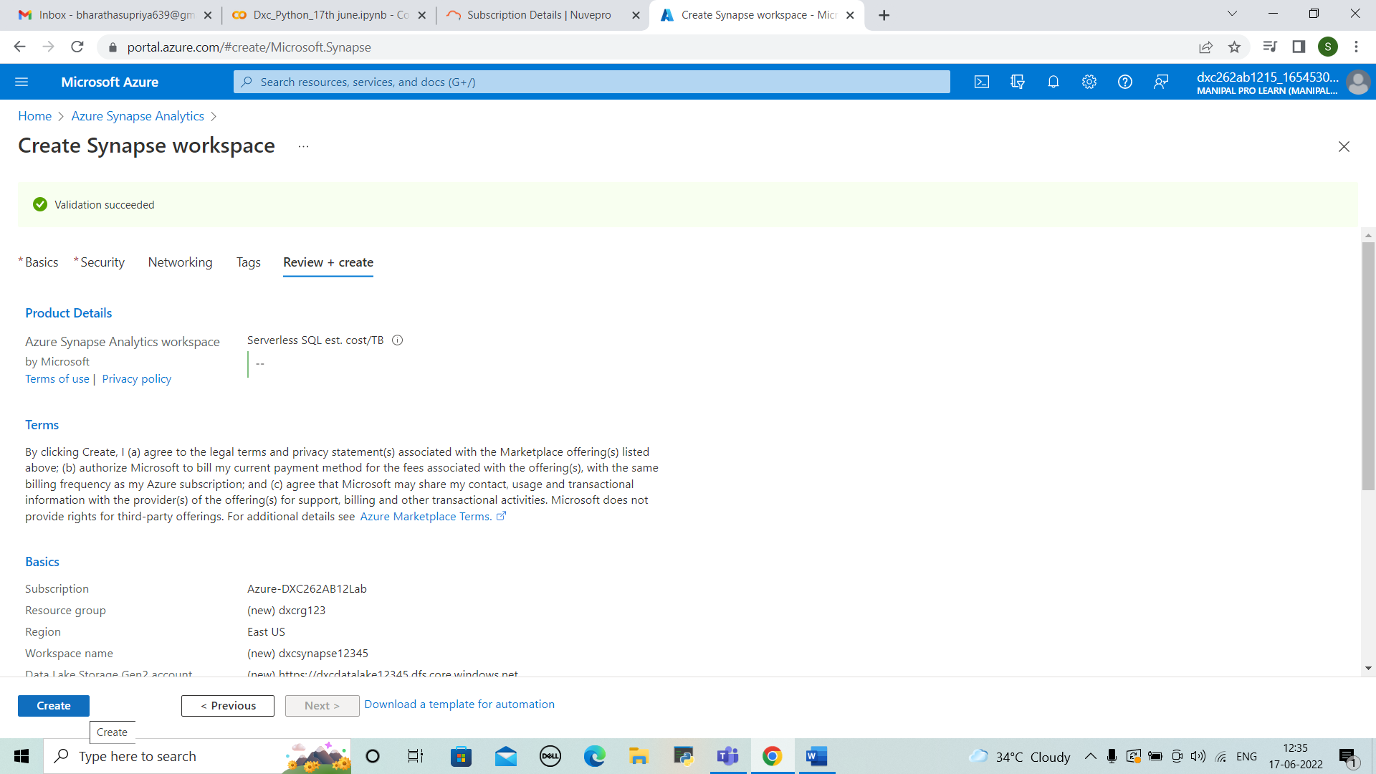



STEP 5: The deployment is completed.

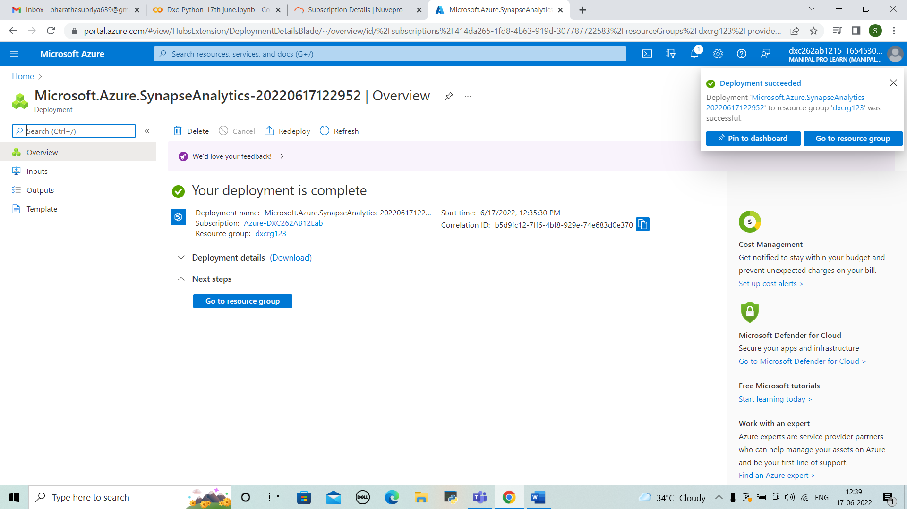



STEP 6: We can view the overview of synapse analytics. Open the synapse studio.

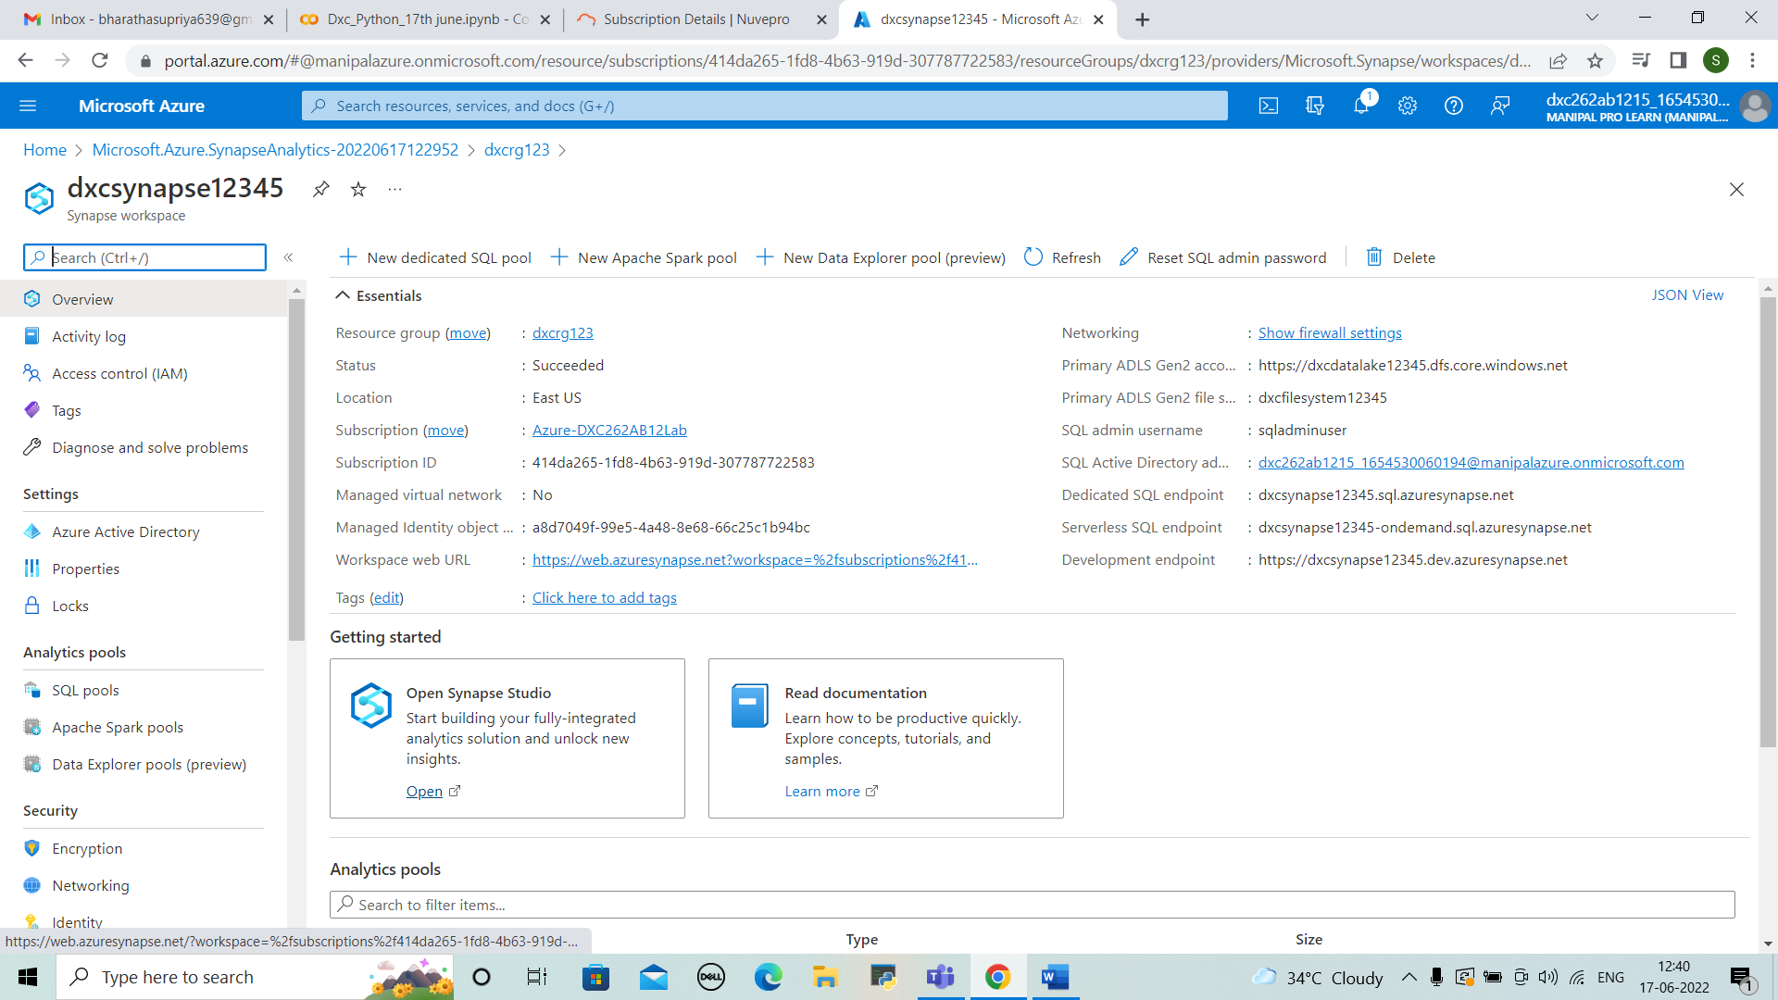



STEP 7: Create storage accounts by entering the details and complete the deployment. And create the container in it.

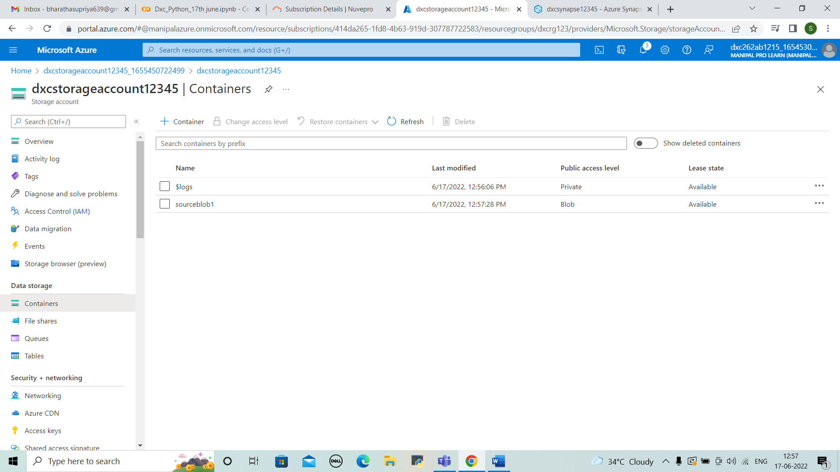



STEP 8: Upload any type of files . Here, I uploaded 4 files. Both of csv and other two of json.

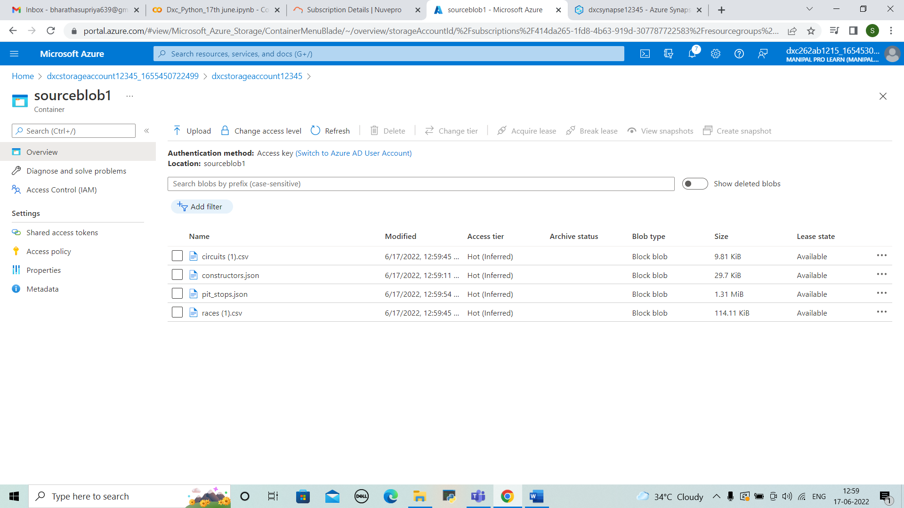



STEP 9: Coming back to synapse analytics for linking synapse with blob storage. Click on Author and “+” > Connect to external data.

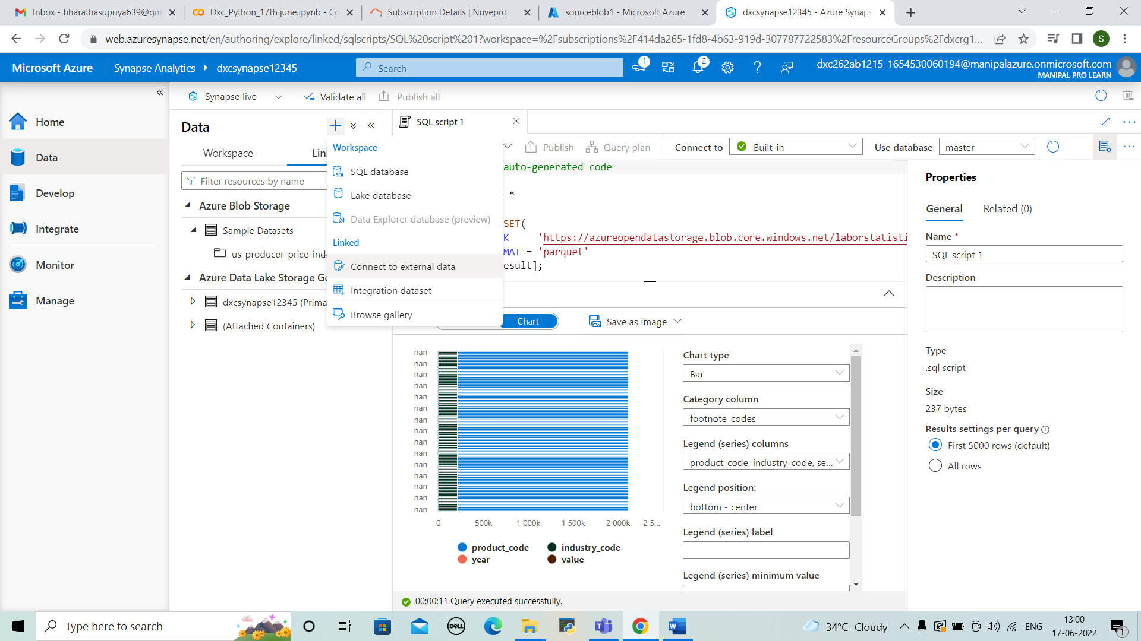



STEP 10: Select the blob storage account and click continue.

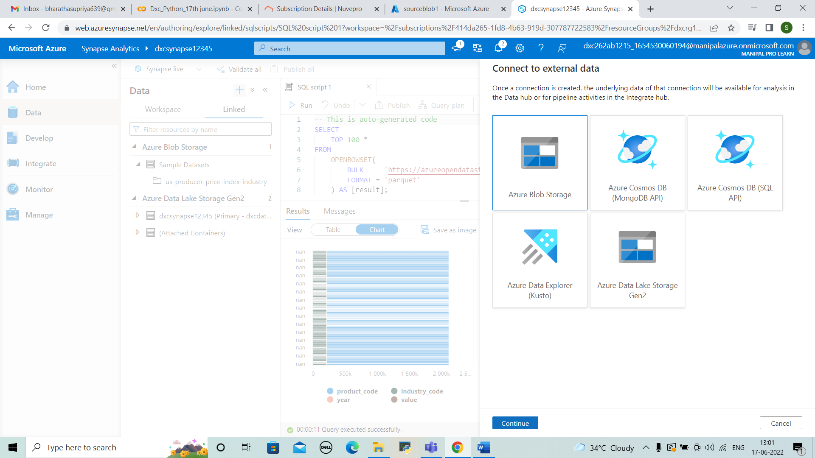



STEP 11:Enter the details of subscription and storage account name and test the connection and click on create. And the connection between synapse and blob is done.

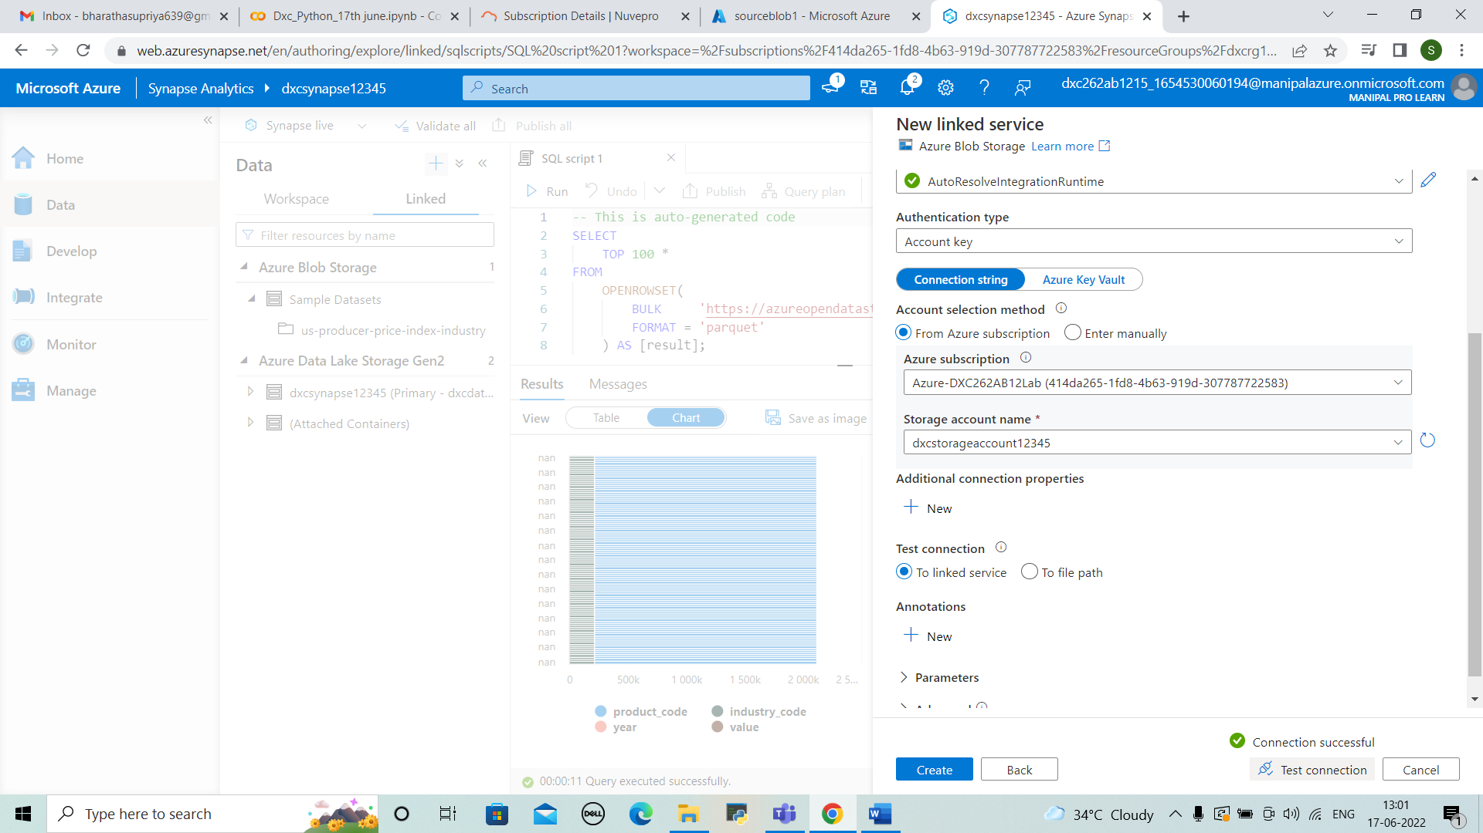



5.Create Azure Synapse spark pool & query sample sample JSON file, explain the steps with screenshots

SOLUTION

STEP 1: After the connection is done .We need to select the apache spark pool.

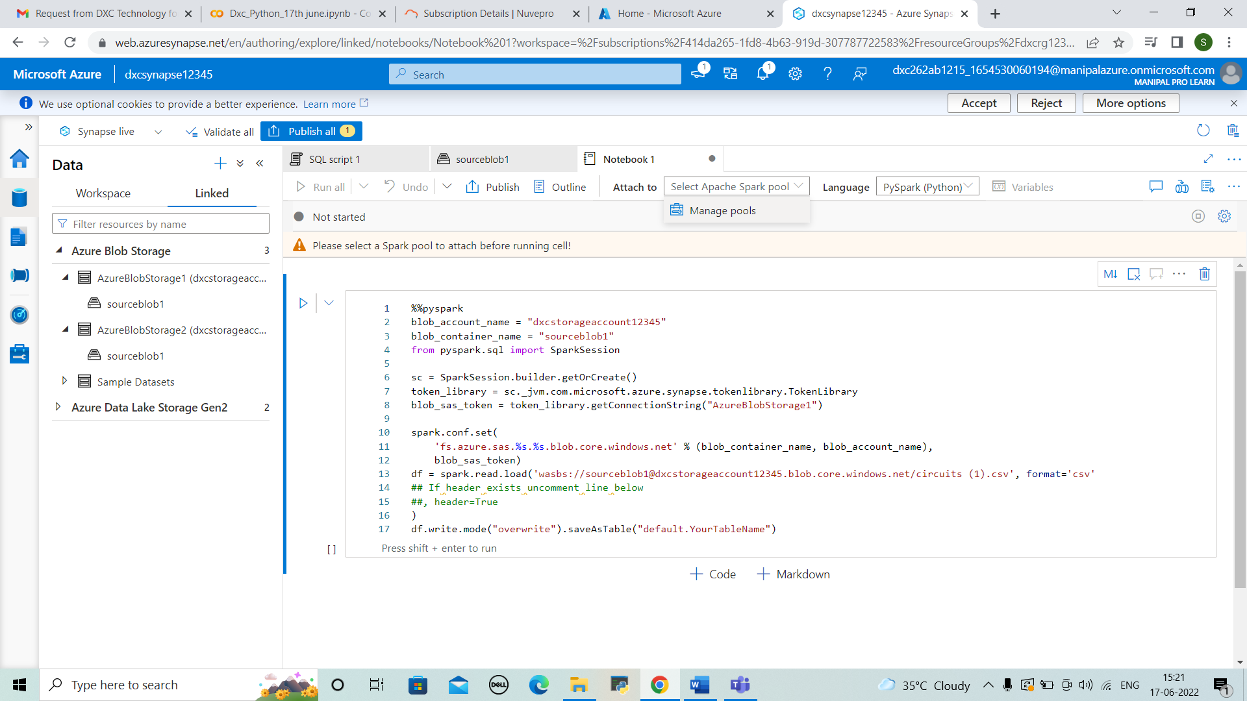



STEP 2: Now create a new apache spark pool by entering the details.

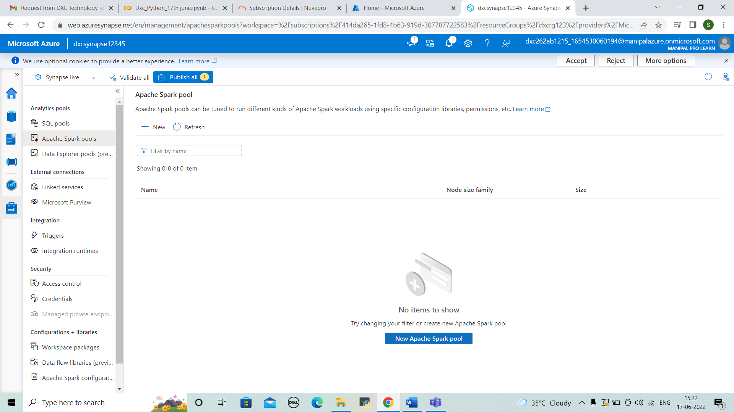



STEP 3: Select the spark that created previously and then run it. And we can view the data in result. And that can be also viewed in chart format of tables, line graphs , pie charts and etc..

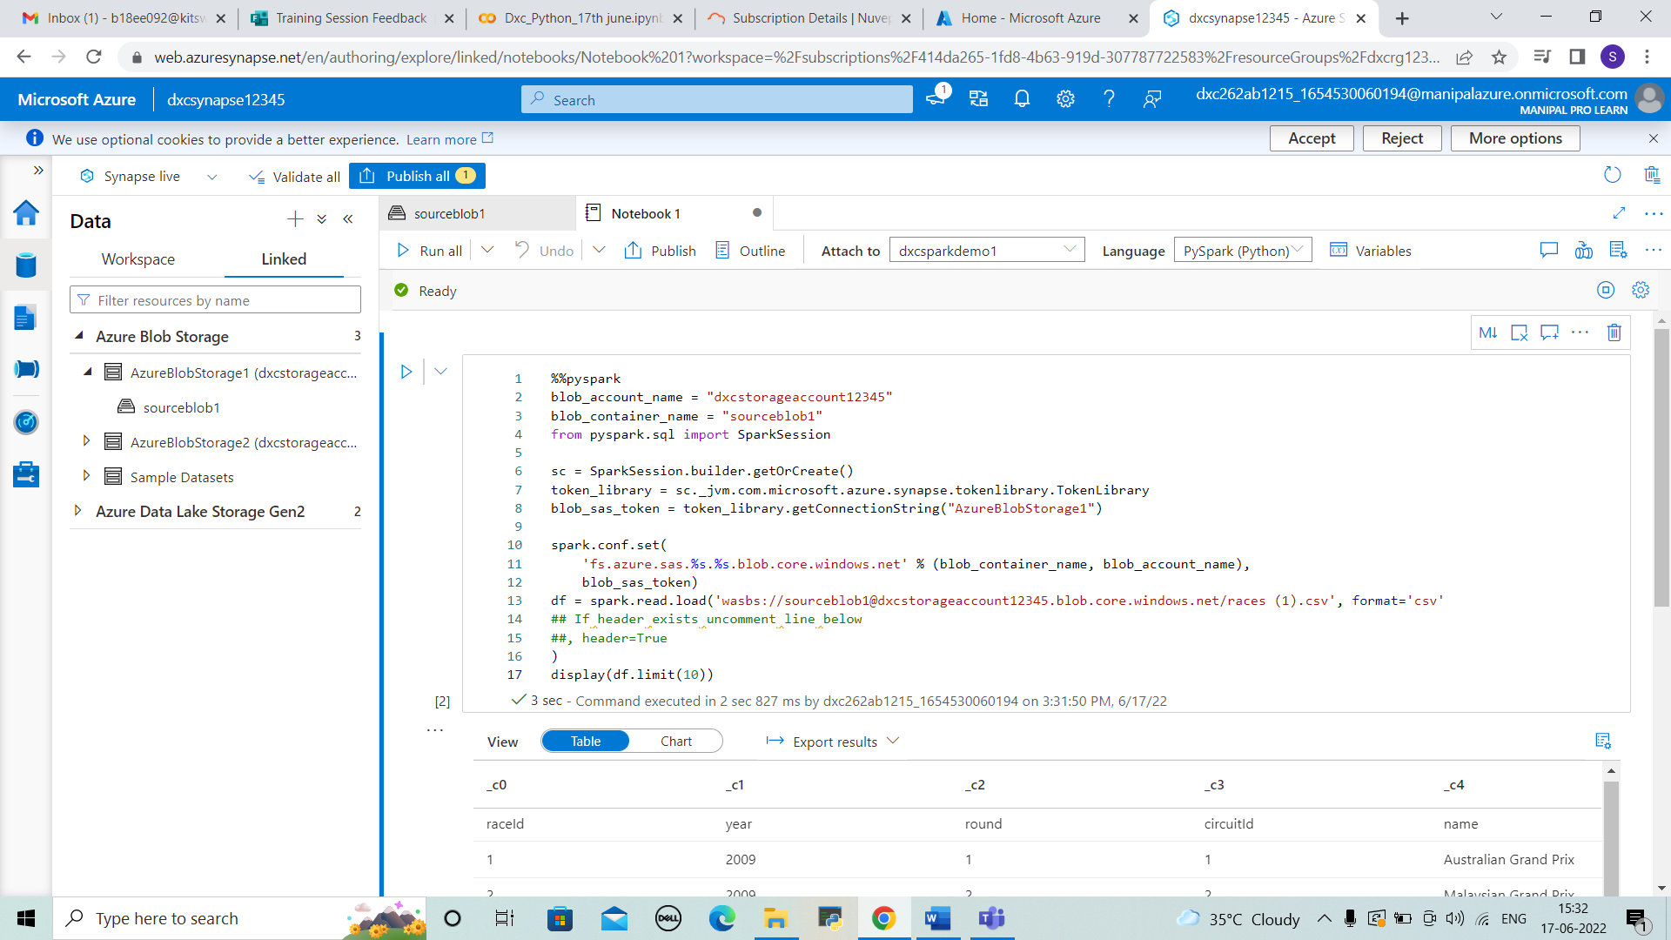



6.Create Azure Cosmos DB & import sample JSON file, explain the steps with screenshots

SOLUTION

STEP 1: Open azure portal search for azure COSMOS DB. And select it.

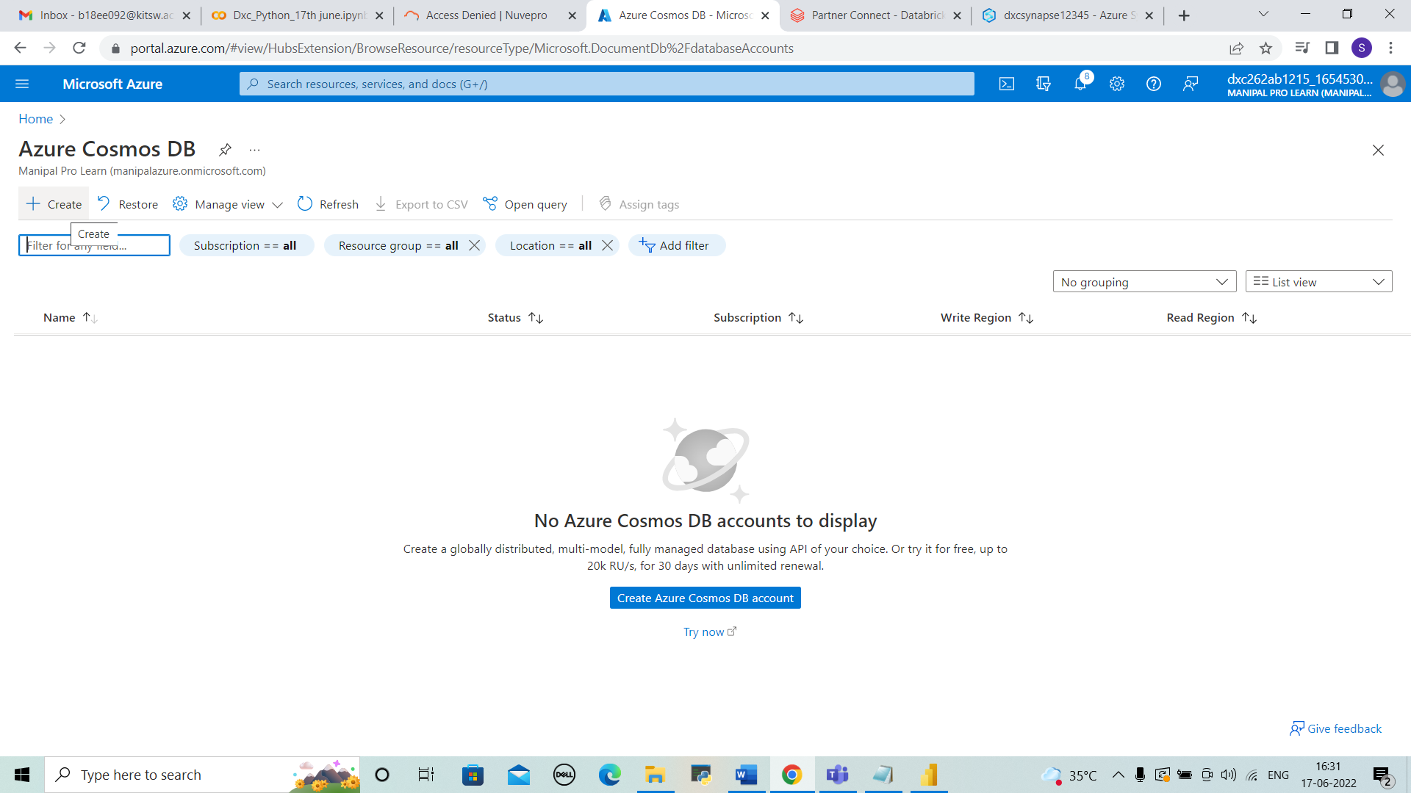



STEP 2: select core SQL and click on “create”.

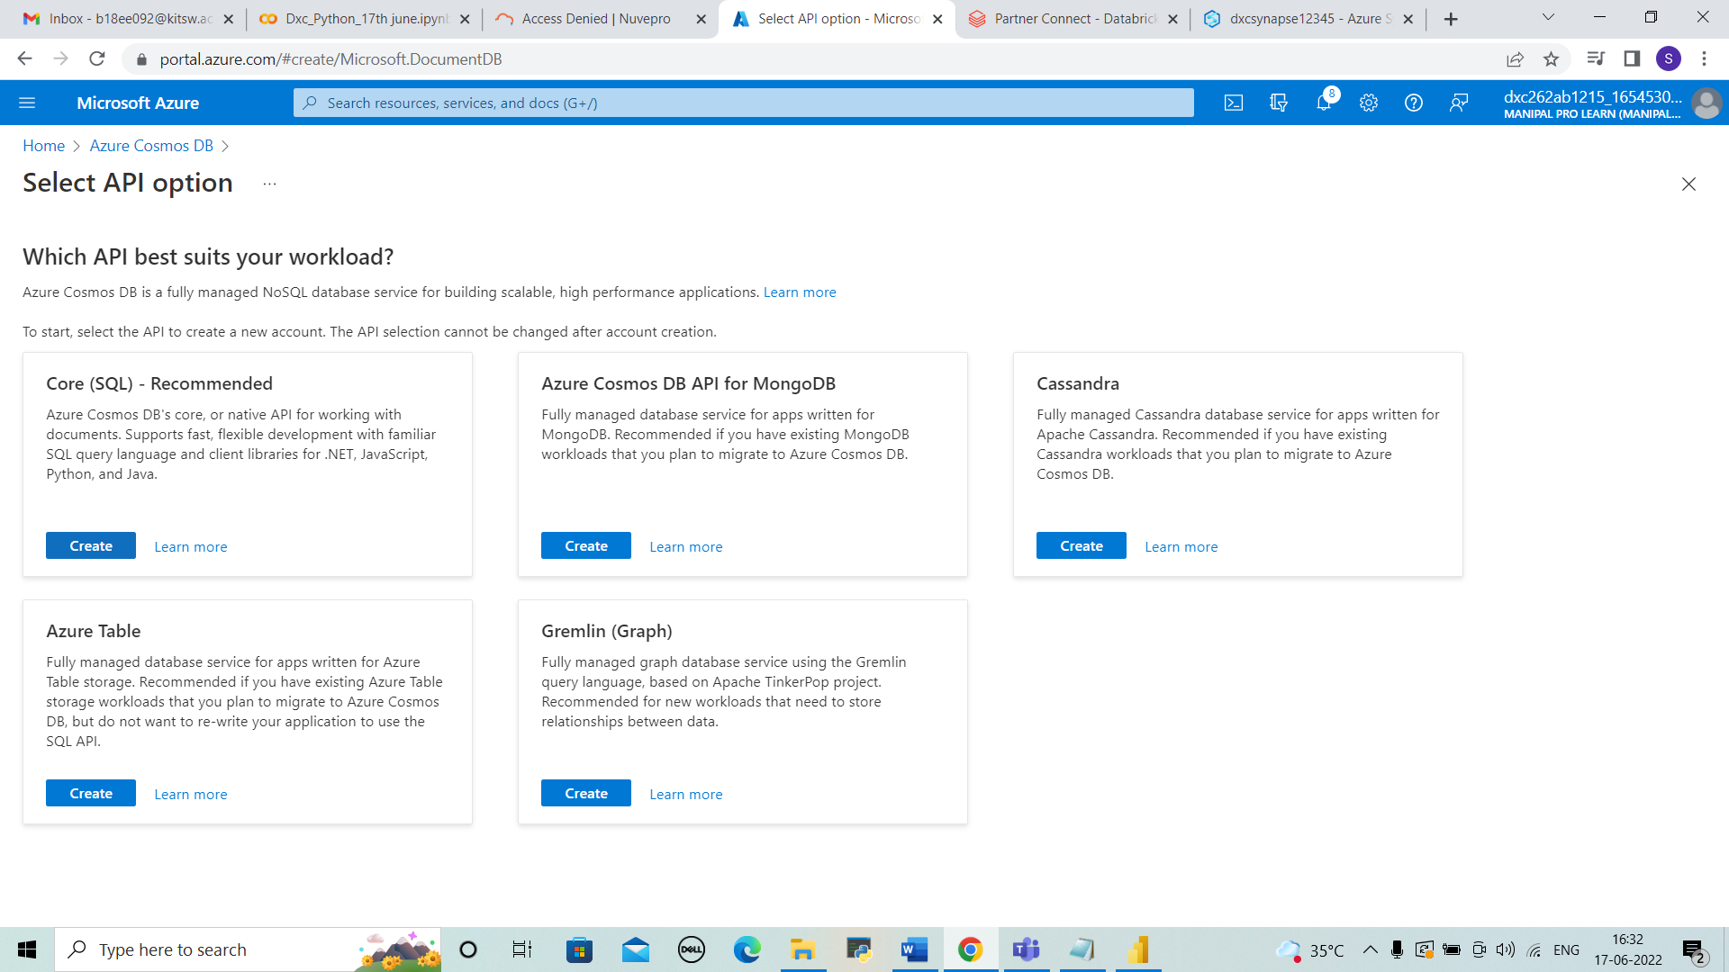



STEP 3: Enter the details of resource group and account name and location and click on review+create.

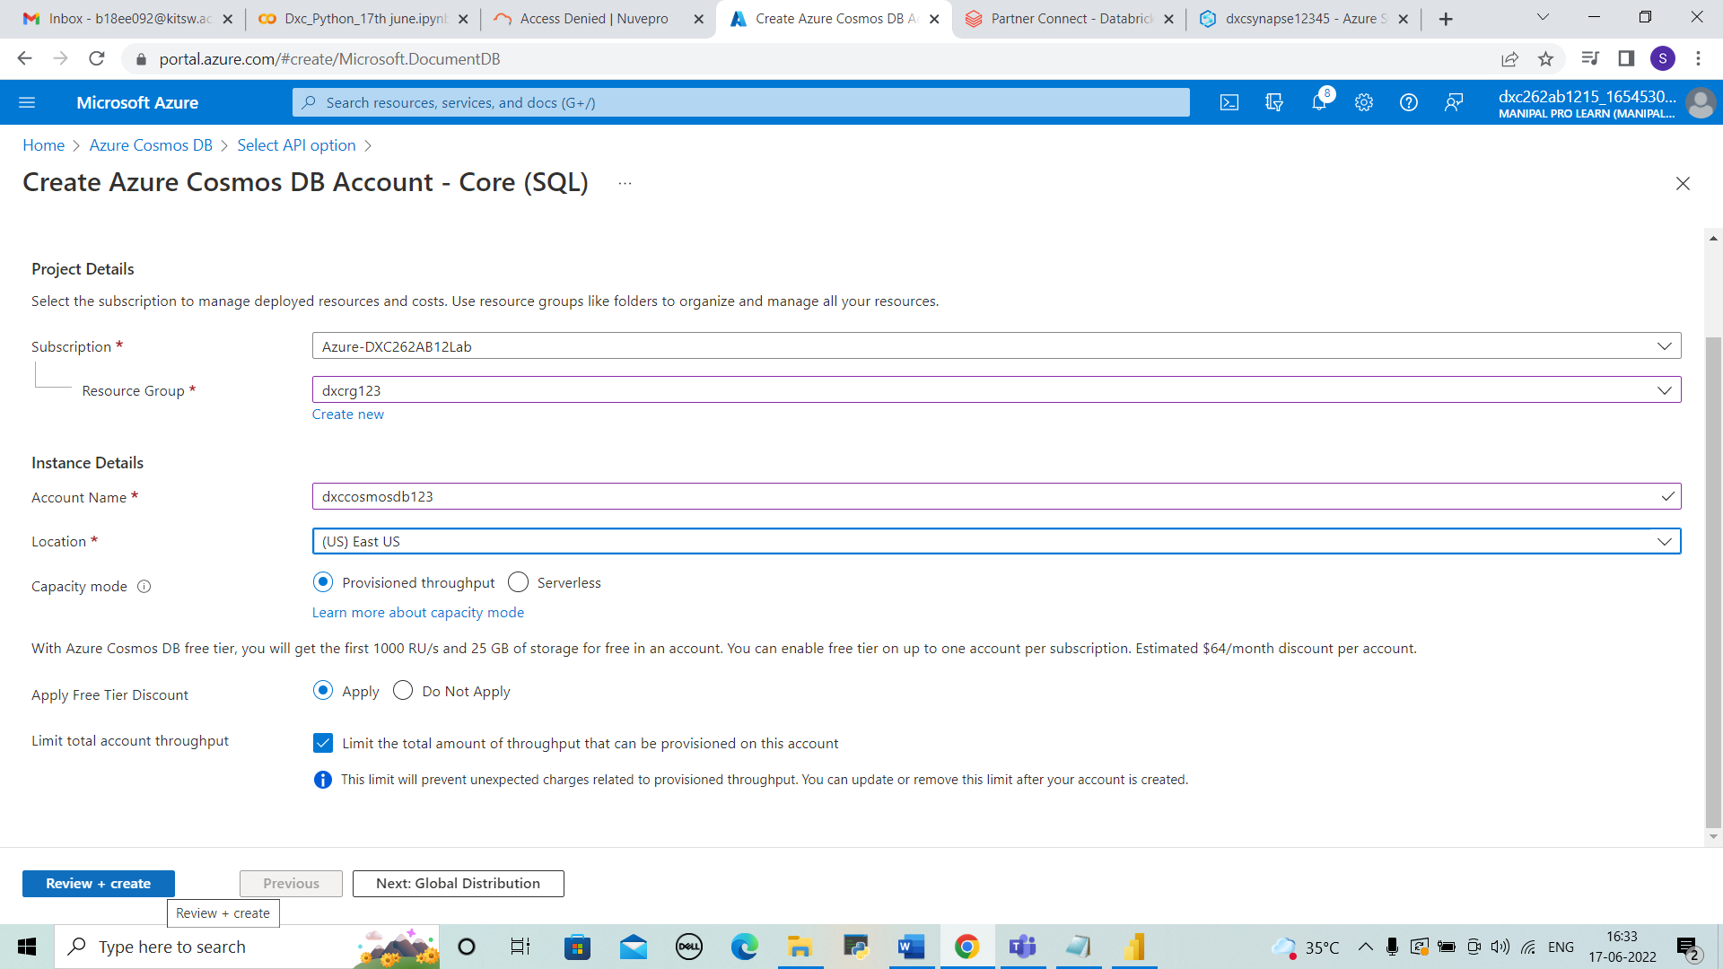



STEP 4: The deployment is completed. Then go to resource .

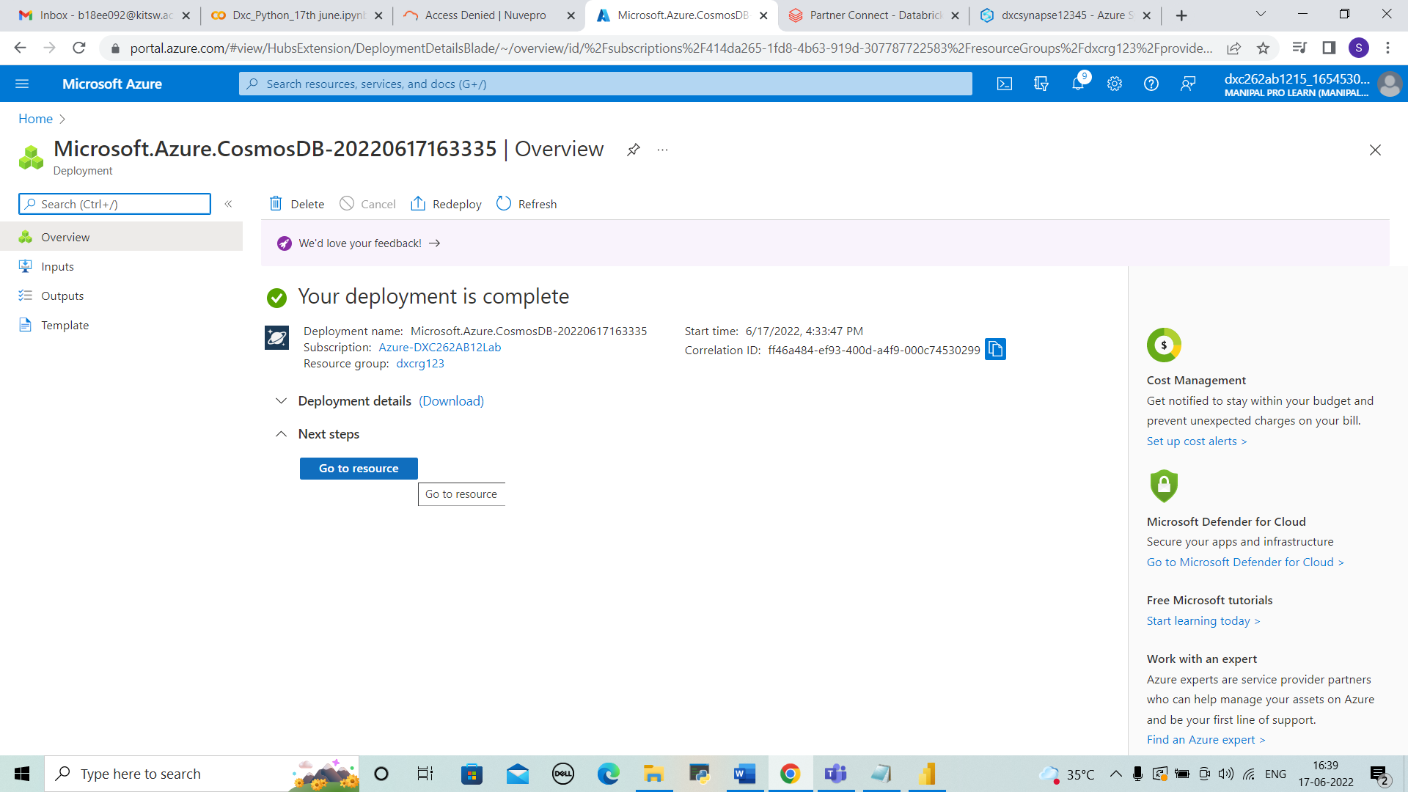



STEP 5: Overview is shown in resources. Click “+ container” And created the container by entering the details .

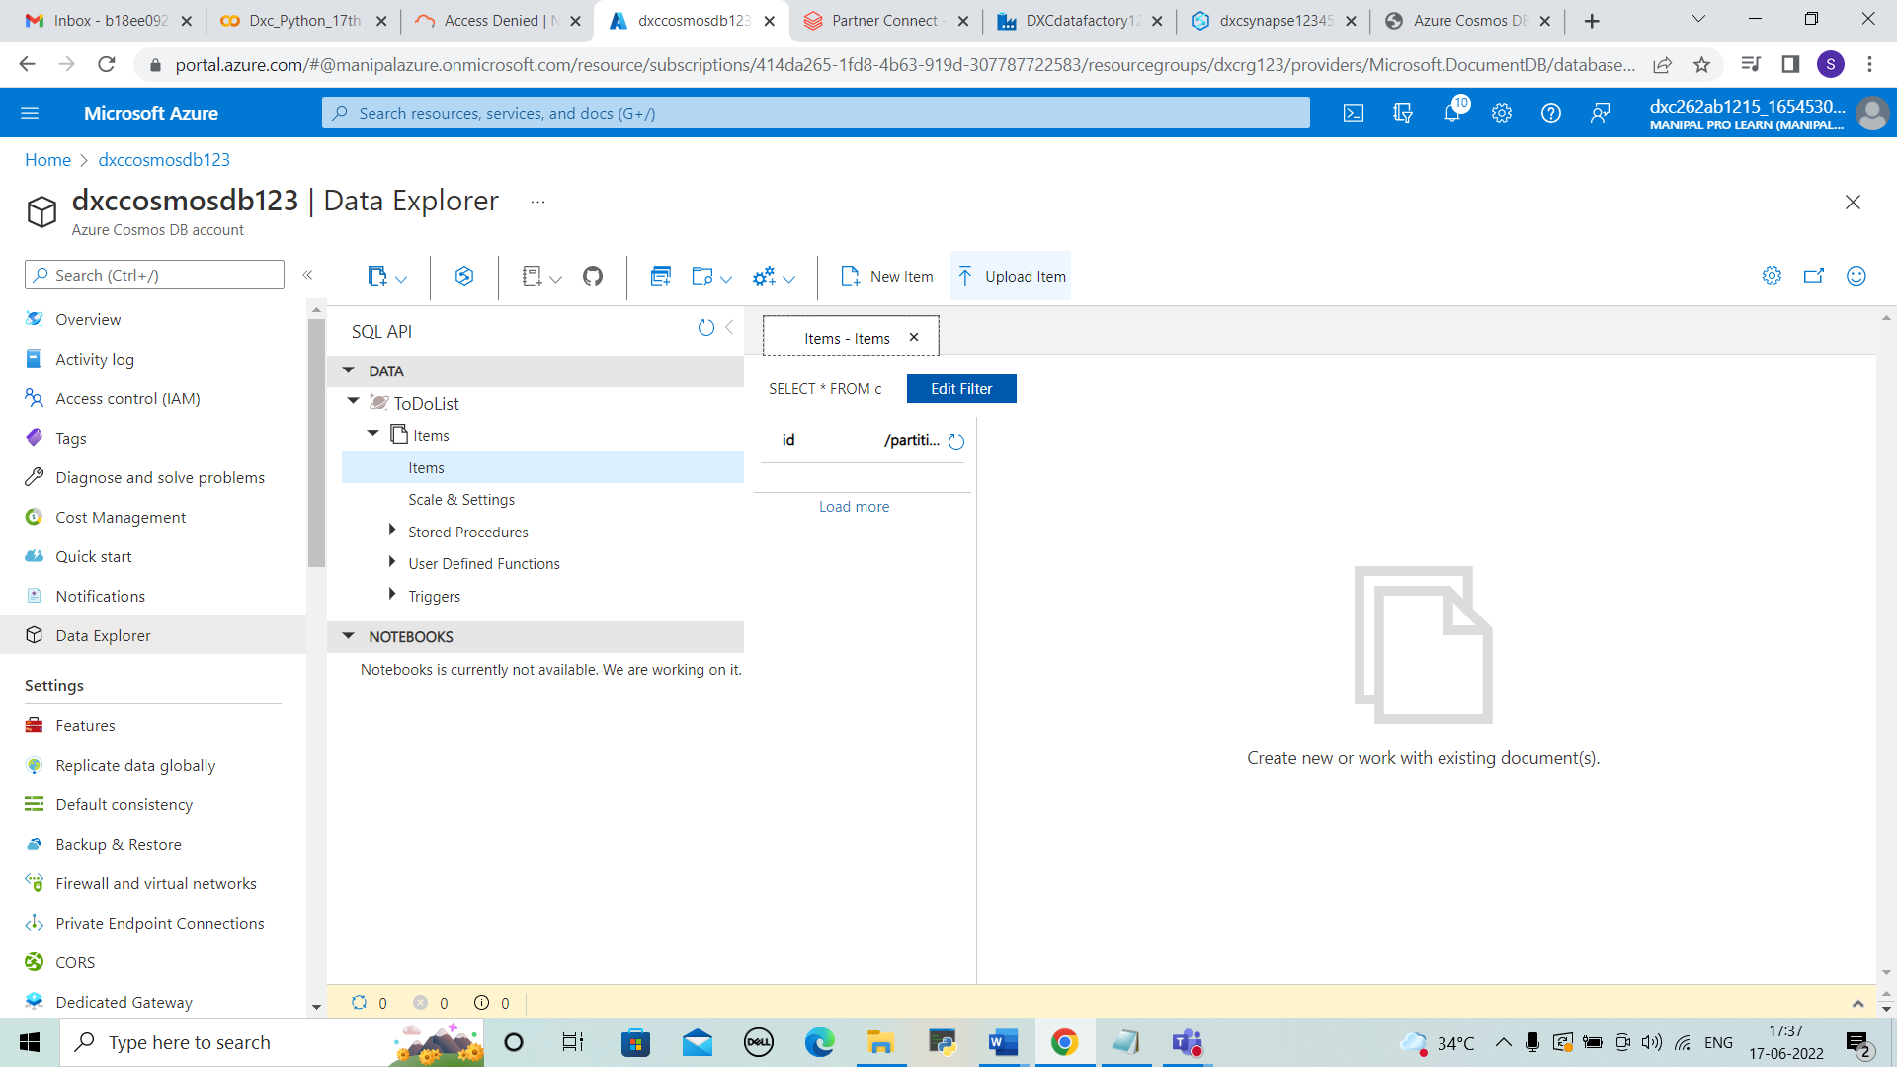



STEP 6: Click on upload. And upload the json file.

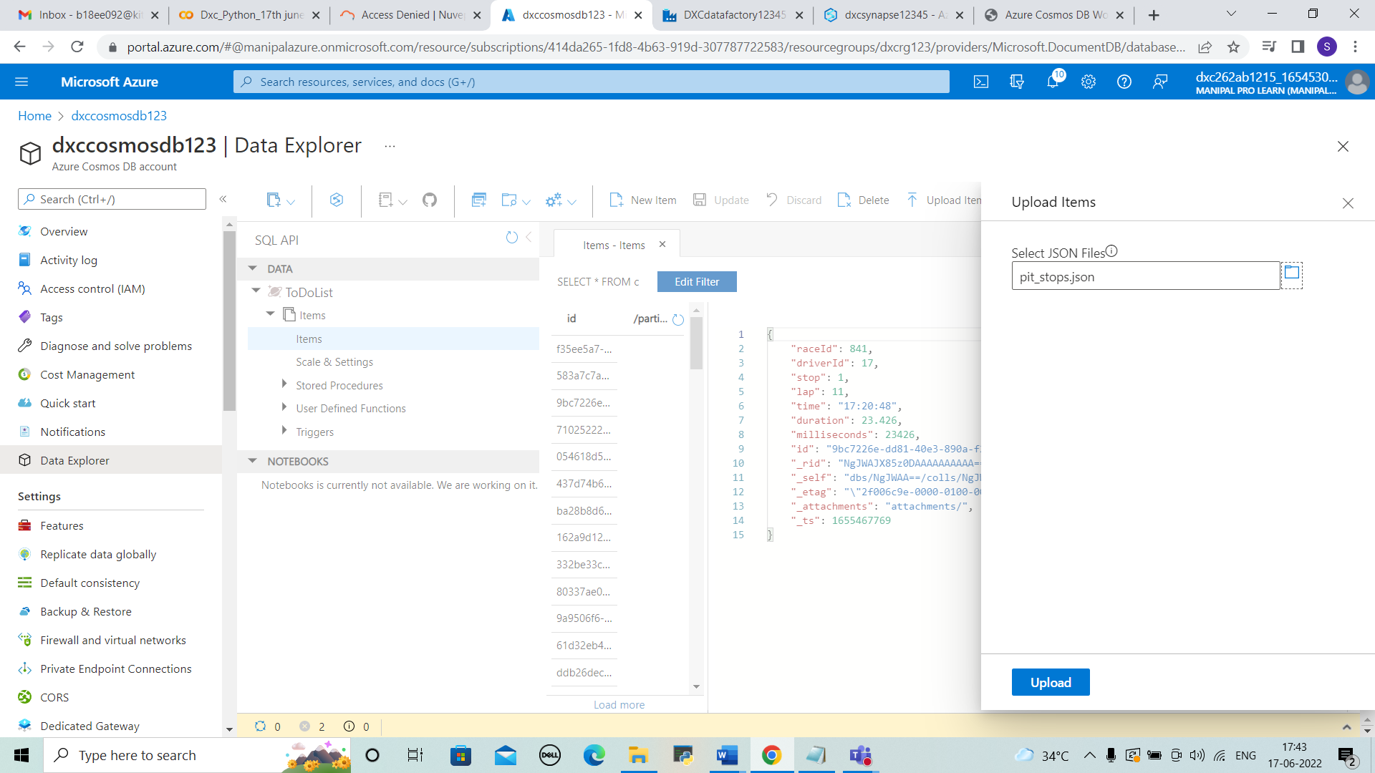



STEP 7: The data can be viewed in the cosmos db the is uploaded.

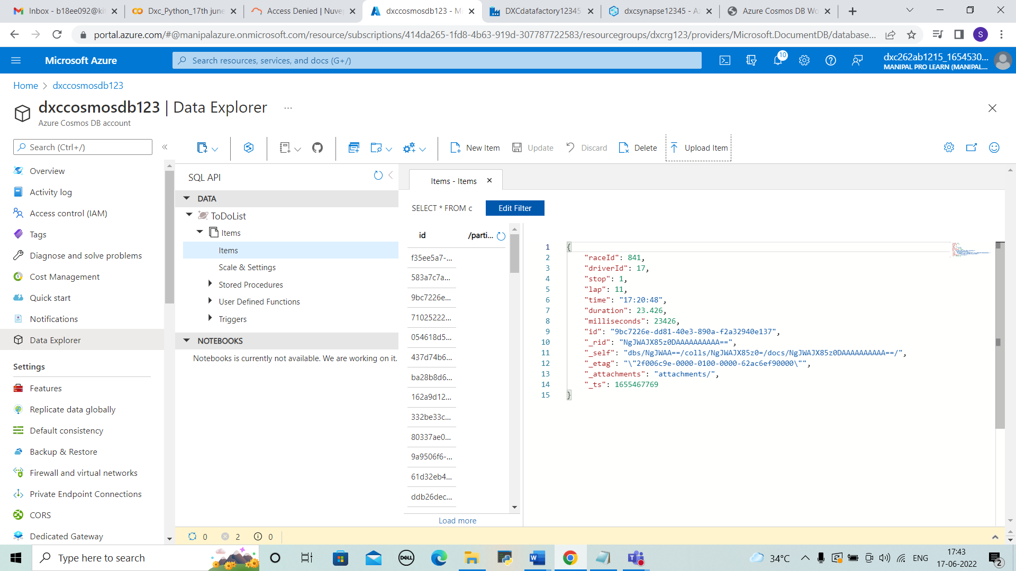



7.Connect COSMOS DB & Azure Synapse analytics & explain the steps with screenshots

SOLUTION

STEP 1: After creating the azure synapse . In author section we can see “+” .There we can link the COSMOS DB .Click on “+” > connect to external data.

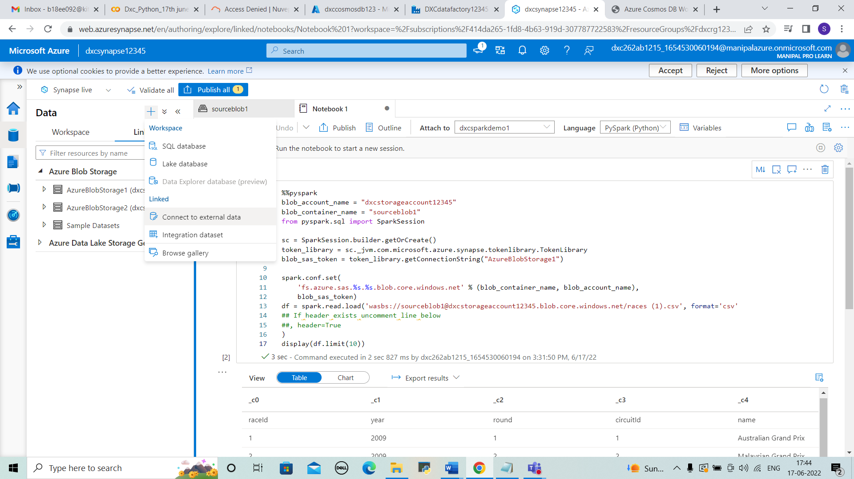



STEP 2: After that we have to select cosmos db and continue.

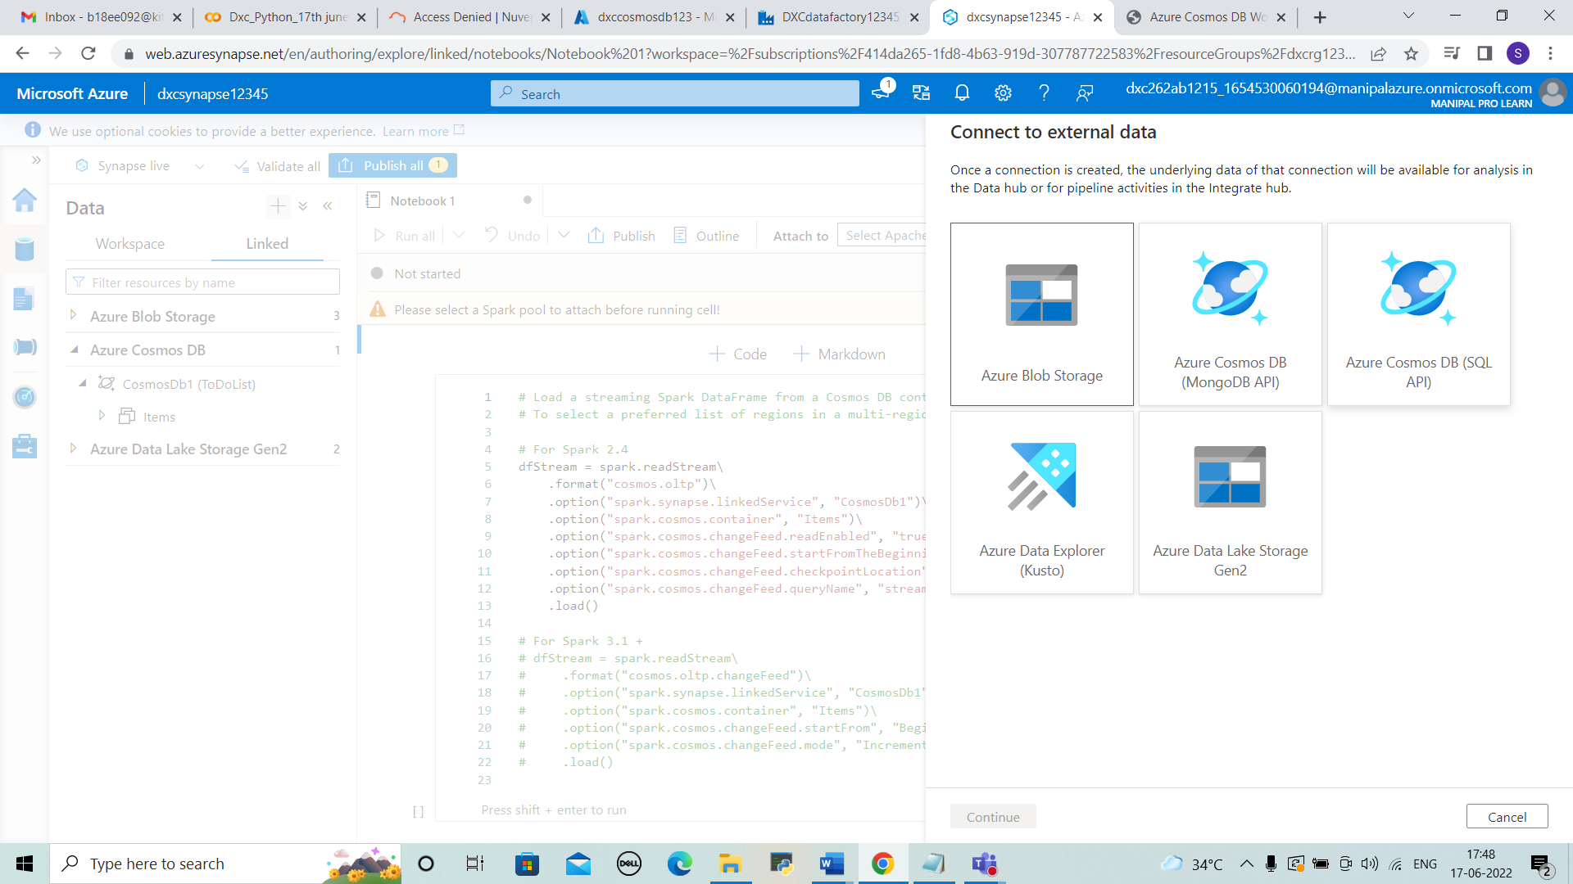



STEP 3: Enter the subscription and account name and database name . And test the connection and click on create.

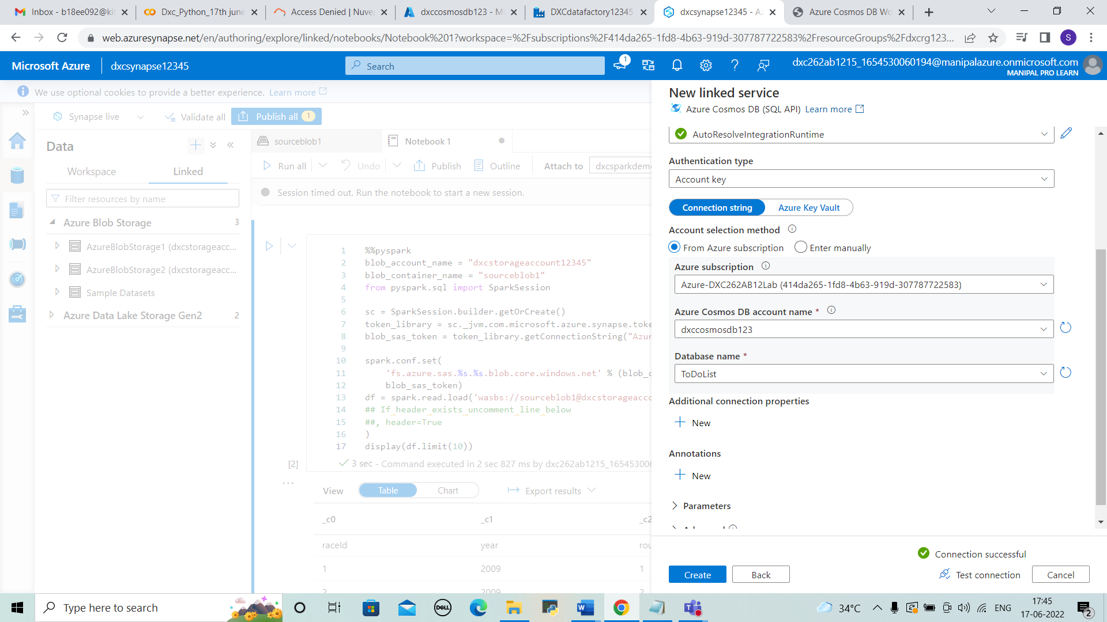



STEP 4: Then refresh the page to view the data in cosmos db that added previously , and open the file that is uploaded in cosmos db.

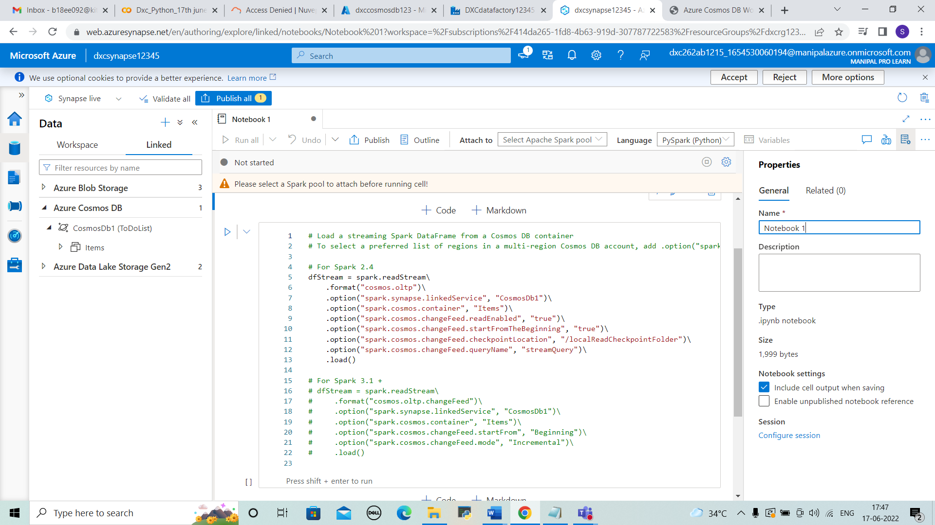

8.Create azure Data factory & azure Blob, connect Blob & ADF,import blob files into Data factory & explain the steps with screenshots

SOLUTION

STEP 1: Open azure portal , Search for Data factories and click on “+ create”.

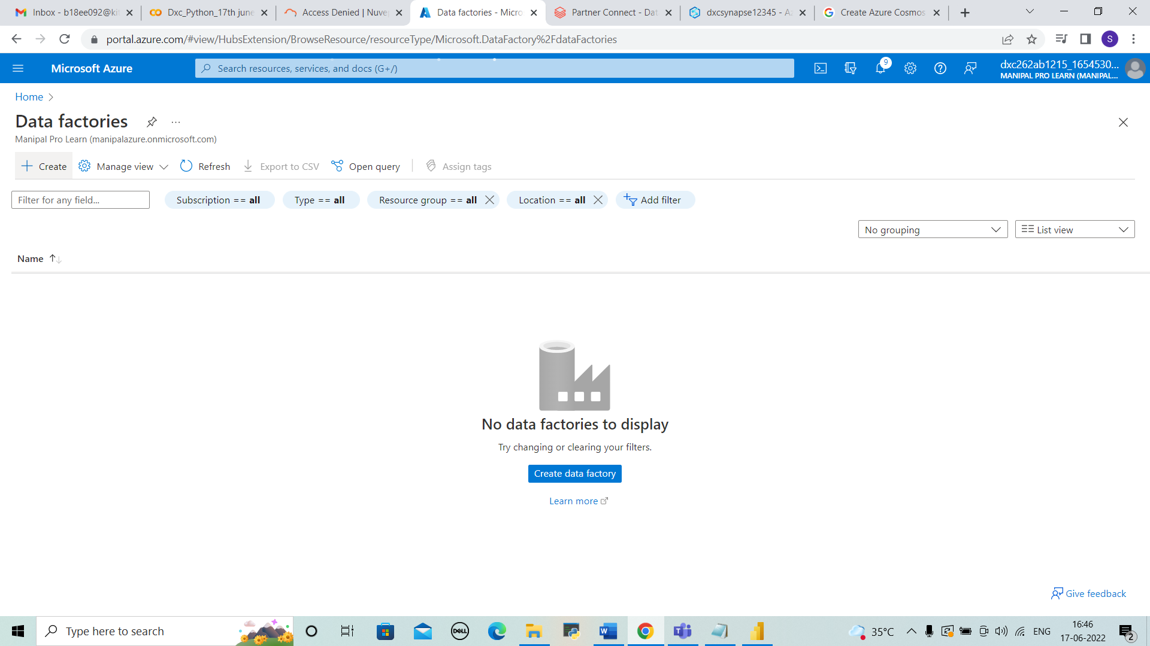



STEP 2:Enter the details of resource group, name, region, version and click on Next:Git configuration.

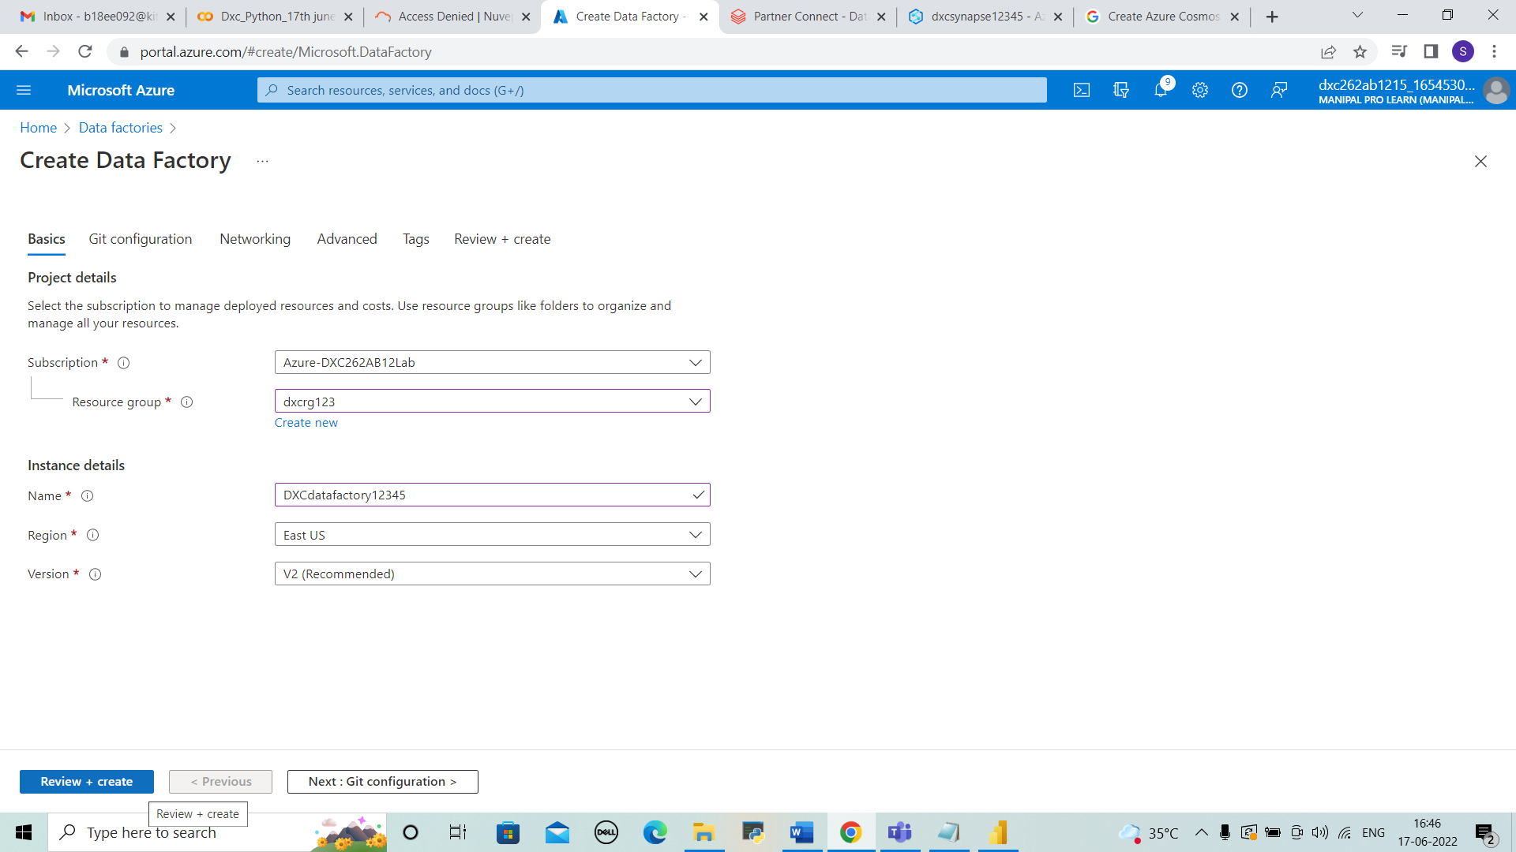



STEP 3: Select configure git later and click on review + create.

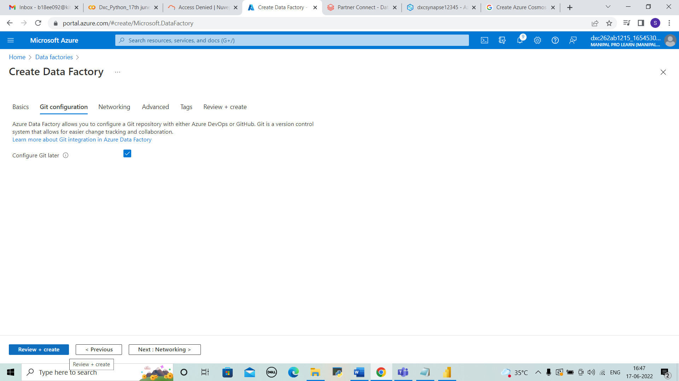



STEP 4: validation is passed and select create. The Deployment will be in progress.

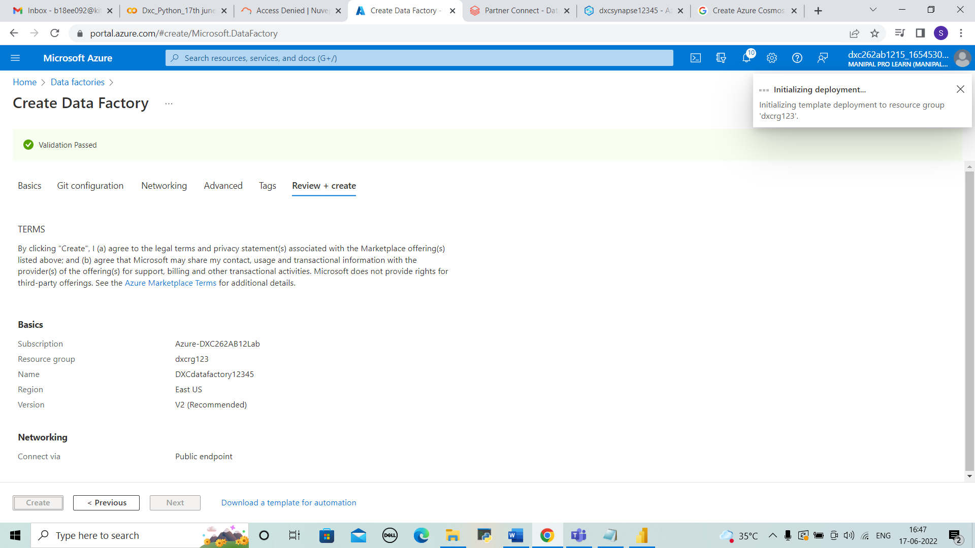



STEP 5: The deployment is completed and then go to resource.

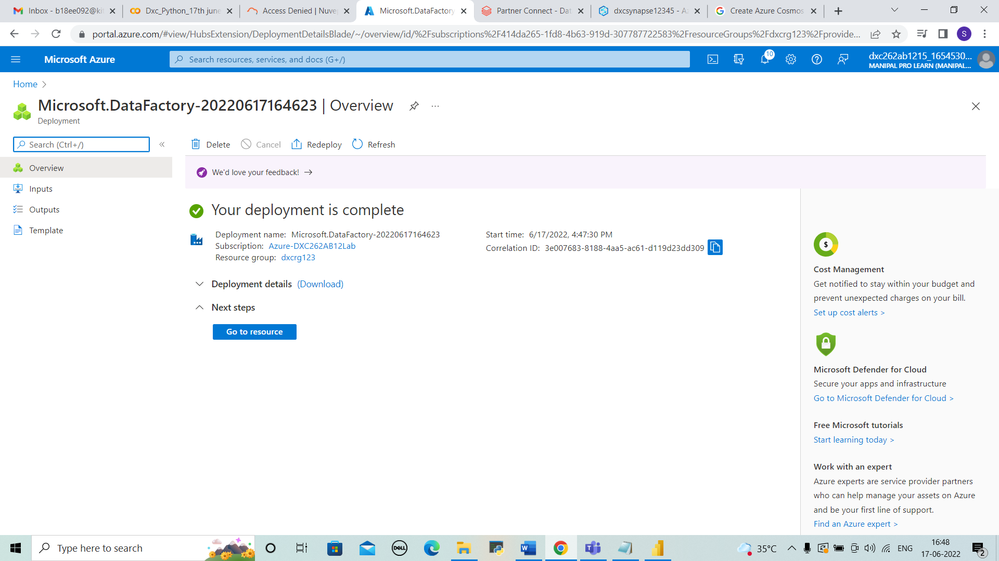



STEP 6: We can view the overview of data factory that create. Select or open azure data factory studio.

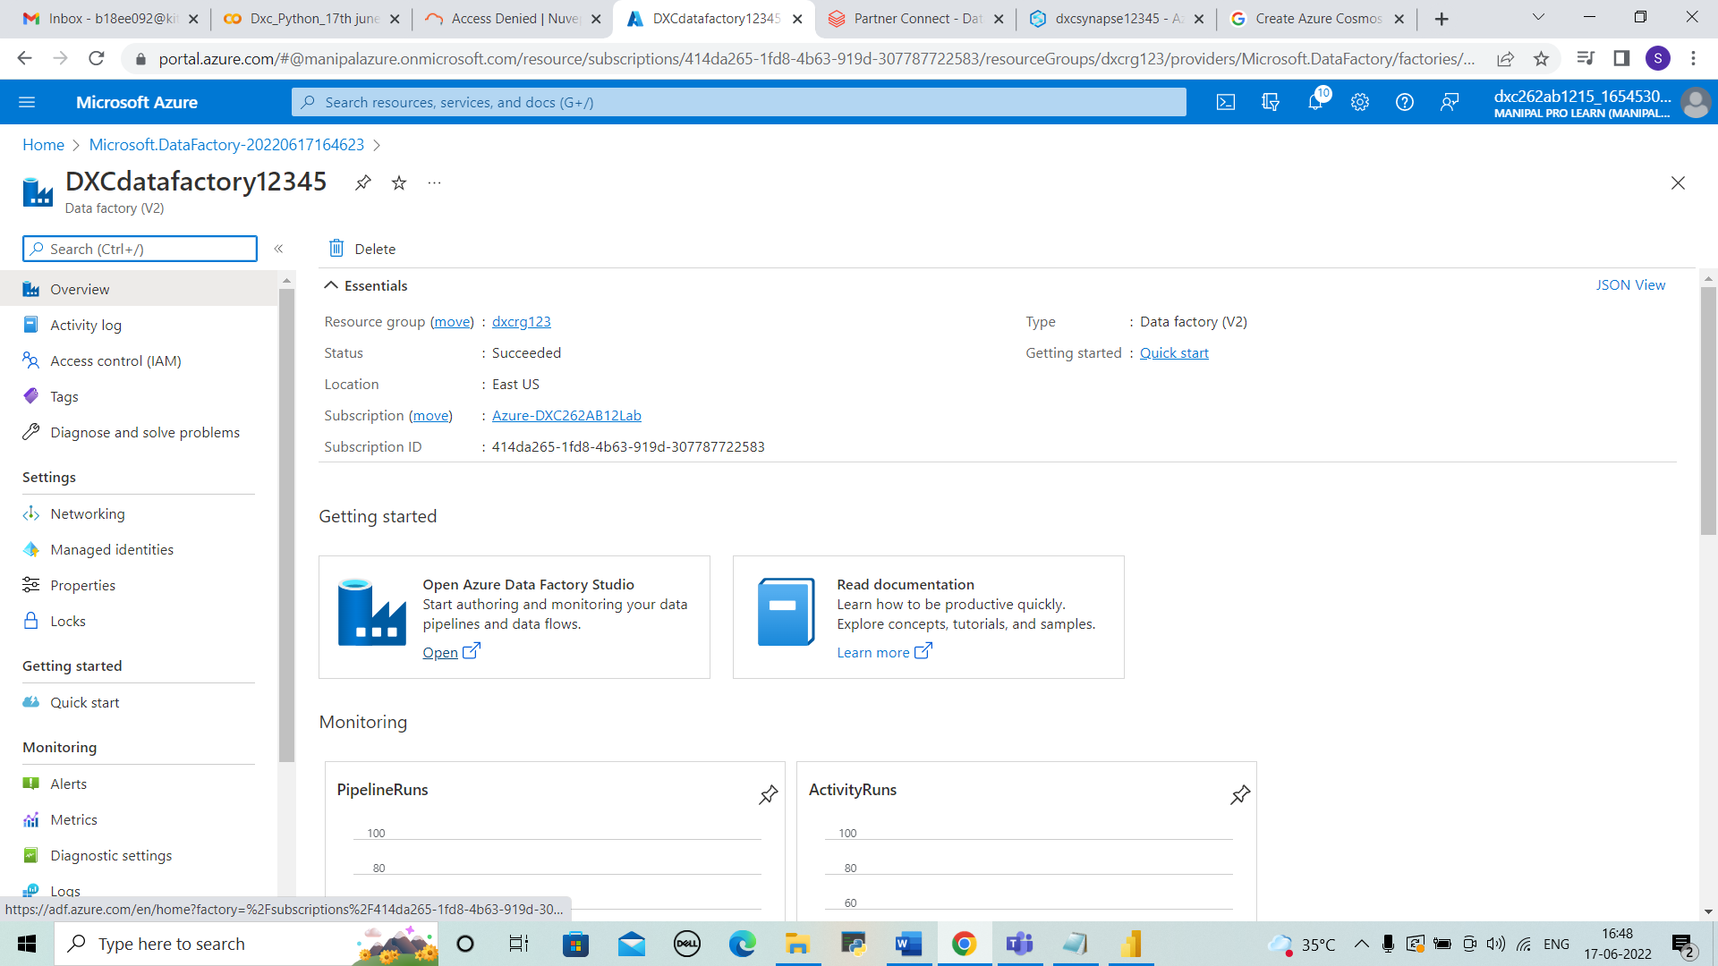



STEP 7: The data factory page is shown and then select manage on the left side.

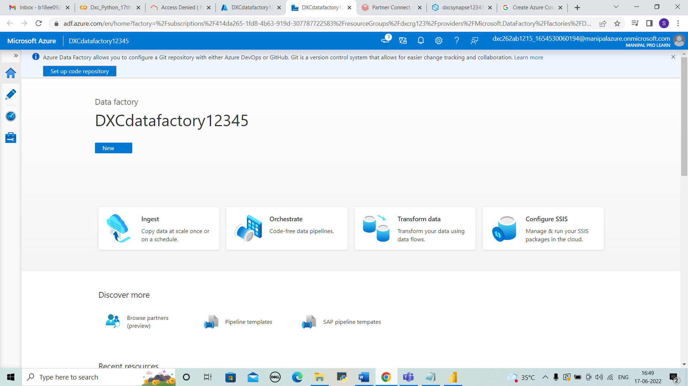



STEP 8: In manage select linked services and click “+New” .

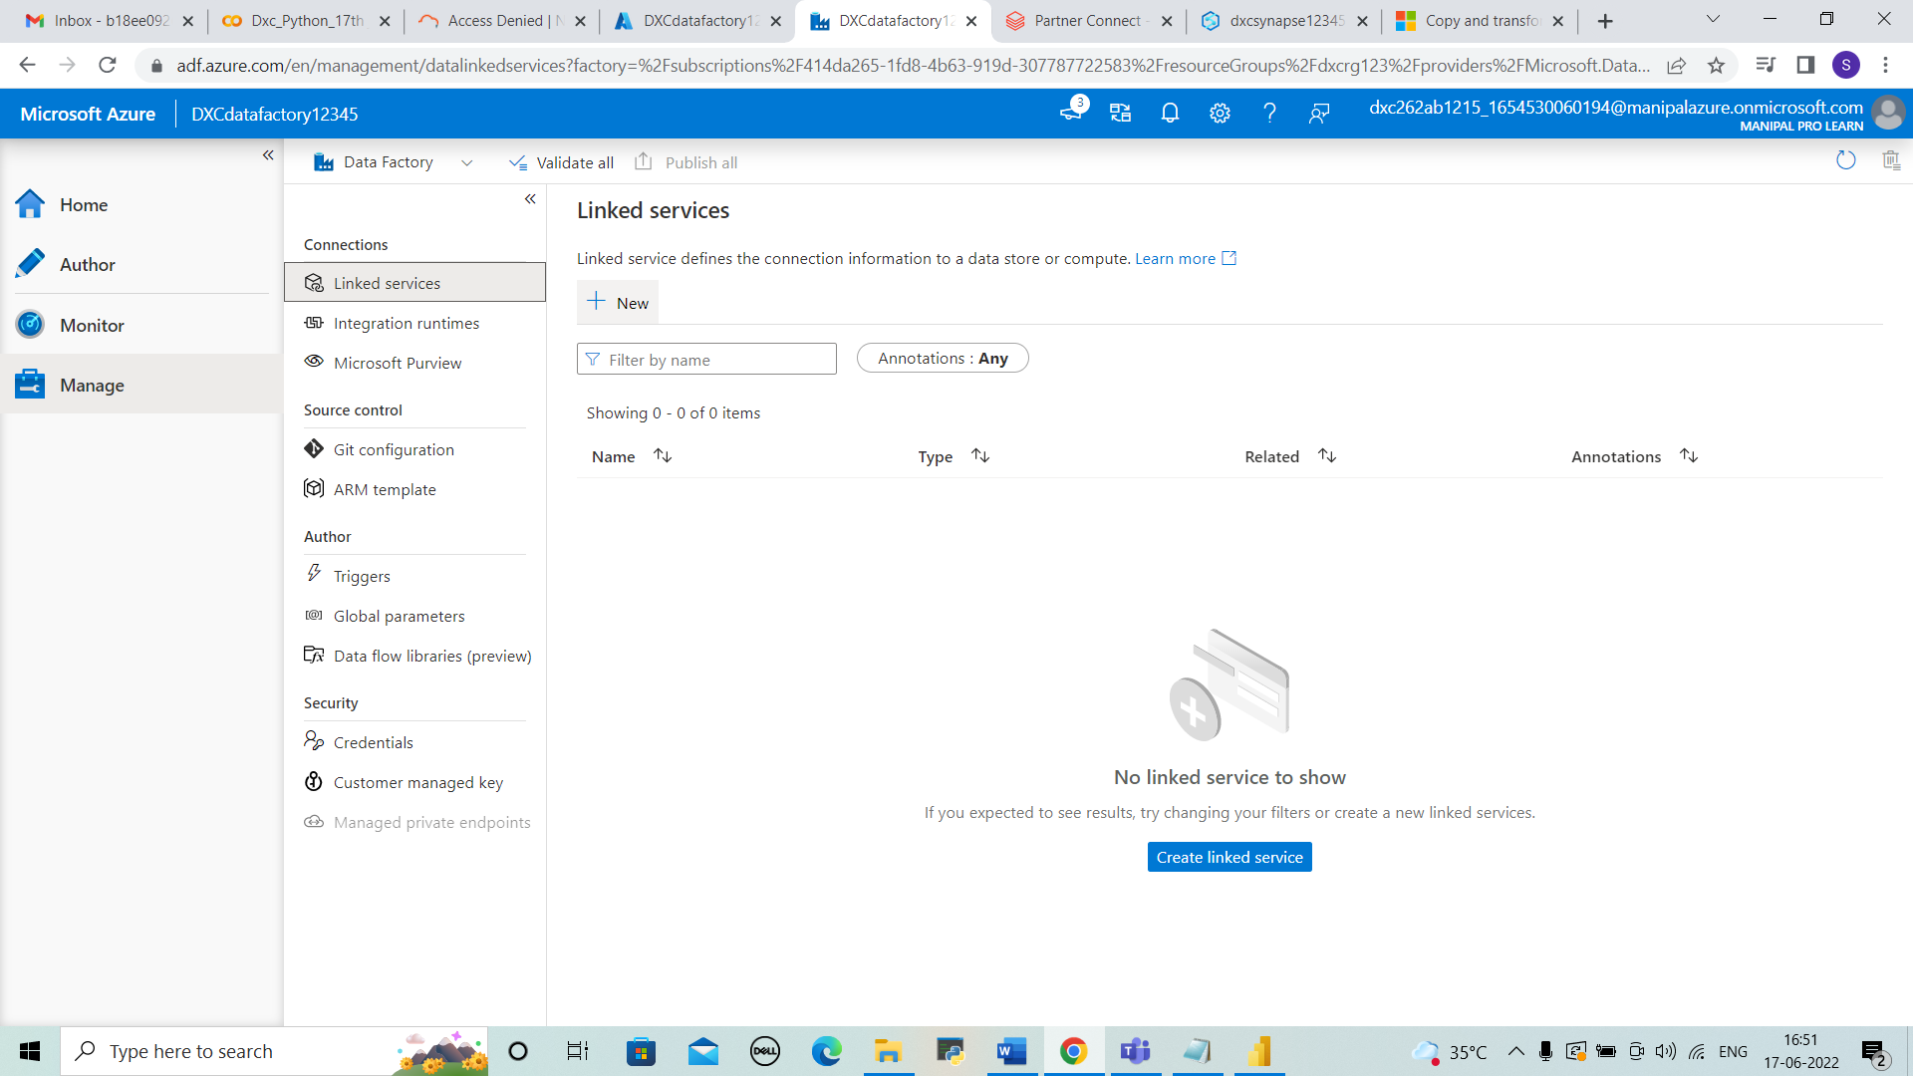



STEP 9: There we can link the new service. Here we need storage account and continue.

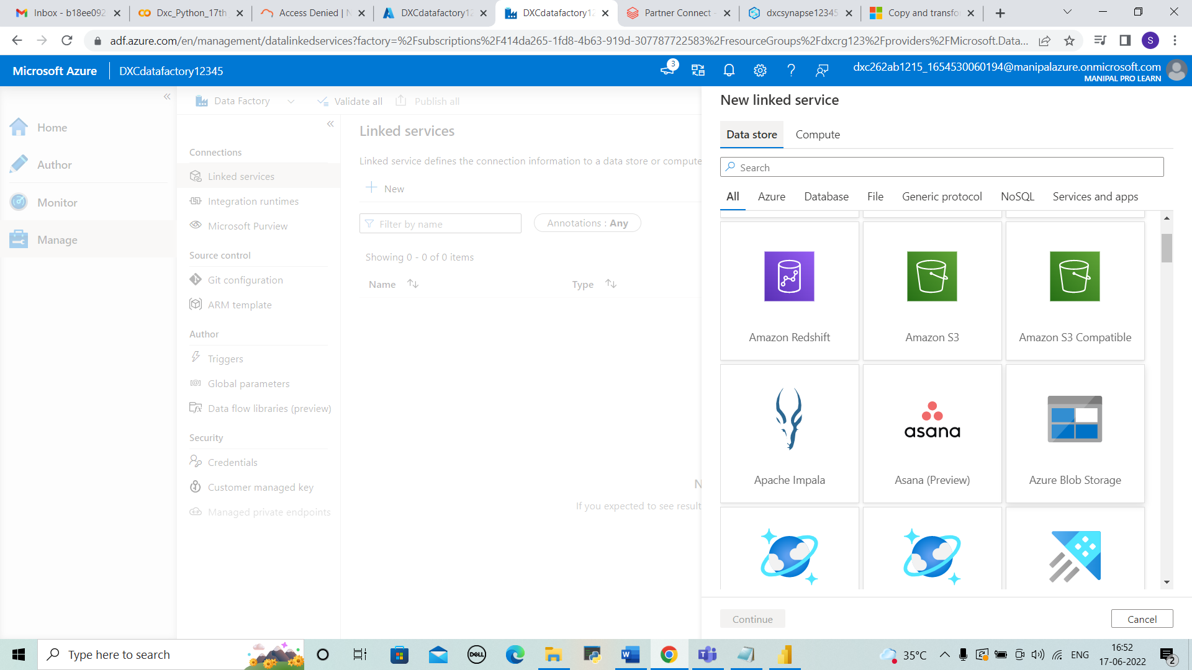



STEP 10: Enter the details of azure subscription and account name and test the connection . Then click on create. The connect is done and can see the blob storage account data in it.

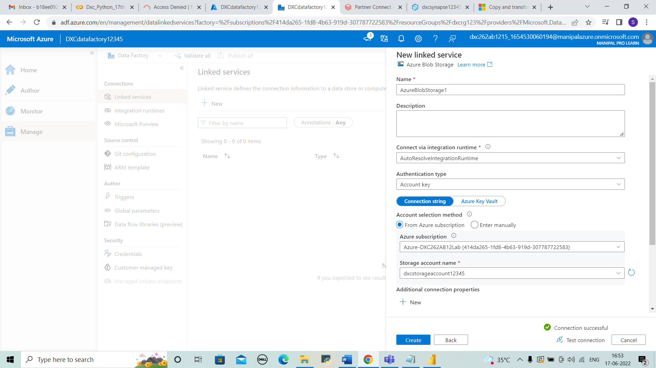



RESULTS:

I HAVE SUCCESSFULLY ANSWERED ALL THE QUESTIONS AS PER ASSIGNMENT REQUIREMENT.

CONCLUSIONS:

All the questions have been solved successfully with all the concepts that have been covered in the training session. It’s really a great experience of learning while solving the cases. This assignment gave me immense confidence regarding my ability to upskill in new technologies.